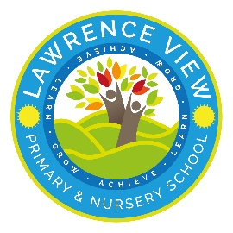
Lawrence View Primary and Nursery School Curriculum overview 2023/24- Year 3
 | Autumn 1 | Autumn 2 | Spring 1 | Spring 2 |  | Summer1 |  | Summer 2
Quality Text  The Literacy Curriculum | Leon and the Place Between  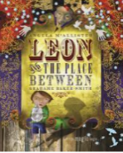  The Heart and the Bottle  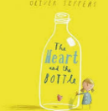 | The BFG  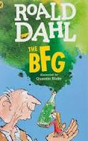  The Tear Thief  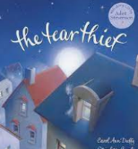 | 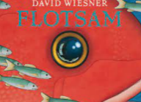  Flotsam  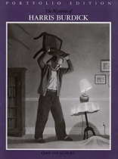  The Mysteries of Harris Burdick | Cloud Tea Monkeys  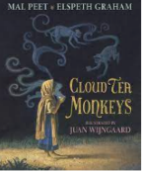  Sparky  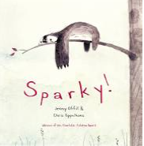 |  | 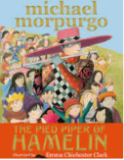  The Pied Piper of Hamelin  Escape from Pompeii  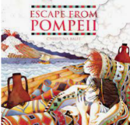 |  | Jim, a Cautionary Tale  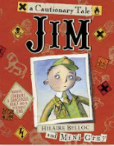  The Day I swapped my Dad for a Goldfish  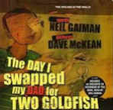
Wow Starter | Talk from Oxfam and Wateraid.  Kindness, respect. | Greek themed day – food tasting and dancing.  Visit from the Blind society/guide dogs. | Den building in outdoor Forest Area.  Dissecting ‘Stone Age poo’  Cave drawings under the table.  Resilience, creativity. |  |  | Jelly Earthquakes.  Fire safety  Visit the Galleries of Justice. |  | Prepare their own allotment space on the school grounds.
Enrichment | Greek experience day – food, dancing and learning the language.  Orienteering | Host an art exhibition.  Make a daisy chain.  Make a grass trumpet. | Trip to Creswell Crags. |  |  |  |  | Campout on the field.  Water play  Fly a Kite
Community links | Raising money for aid relief charity.  Link with the Olive Tree for pitta bread donations for Greek food tasting. | Trip to an allotment  Harvest Festival collection. |  |  |  | Local guide dog association.(Phoenix park)  Raise money to support. |  | Visit the local food bank or have a visitor from and collect food to donate.
School values | Kindness. Respect.  Creativity. Aspirations. Resilience. | Creativity. Resilience | Respect  Aspirations |  |  | Aspiration |  | Kindness
British values | - Individual Liberty-Human rights | Democracy- Discuss and vote on best way to raise money | - Tolerance of others-Den building group working /RE |  |  | The rule of law-Galleries of Justice Mock trial |  | Mutual respect
Personal Development | Families  Responsibility | Caring Friendships | Respectful – relationships  Personal Safety | Safety in and around the home |  | Community  First Aid  Democracy |  | Changing and Growing (SRE)  Economic Wellbeing
History Enquiry Question and Theme |  |  | British History- Stone Age/Iron Age  What changed in Britain from the Stone Age to the Iron Age?  Historical themes:  Continuity and change  Significance |  |  | World History- Early civilisations  Was everyone an Ancient Egyptian?  Historical themes:  Evidence  Similarity and Difference  Cause and Consequence
History Key Knowledge |  |  | - Know how Britain changed between the beginning of the stone age and the iron age  - Know the main differences between the stone, bronze and iron ages  - Know what is meant by ‘hunter-gatherers’  Recovery from Y2  - Know what we use today instead of a number of older given artefacts  History Skills  - Place the time studied on a time line  Sequence events or artefacts  Use dates related to the passing of time. •  - Identify and give reasons for different ways in which the past is represented  - Distinguish between different sources and evaluate their usefulness  - Look at representations of the period – museum  - Uses a range of sources, observing small details e.g. internet, library, artefacts and visits to collect information about the past  Asks and answers questions such as: How did people…? What did people do for…?  - Suggest sources of evidence to use to help to answer questions. Select and record information relevant to the study  - Communicate knowledge and understanding in a variety of ways – discussions, pictures, writing, annotations, drama, mode  Recovery from Y2  - Sequence artefacts closer together in time  Able to identify different ways to represent the past  -Uses a source to ask questions e.g why, what, who, how, why, where?  - Begin to assess the effectiveness of sources  -Sequence events |  |  | Know about, and name, some of the advanced societies that were in the world around 3000 years ago  - Know about the key features of either: Ancient Egypt; Ancient Sumer; Indus Valley; or the Shang Dynasty  - History Skills  - Place events from period studied on a time line  - Use terms related to the period and begin to date events.  - Understand more complex terms e.g. BCE/AD  - Begins to use evidence to build up a picture of a past event  - Asks and answers questions such as: What was it like for an Egyptian during?  - Use and suggest sources of evidence to build up a picture of a past event to help answer a variety of questions e.g. library and internet  Recovery from Y3  Place the time studied on a time line  Sequence events or artefacts  Use dates related to the passing of time.  Identify and give reasons for different ways in which the past is represented  Distinguish between different sources and evaluate their usefulness  Look at representations of the period – museum
Geography Enquiry Question and Theme | Why do people go on holiday to Greece?  Geography Key Concepts: Place, space, scale, physical and human processes, environmental interaction and sustainable development, cultural understanding and diversity. |  |  |  |  | Why is Iceland often called the land of ice and fire?  Geography Key Concepts: Place, space, scale, cultural understanding and diversity, physical and human processes
Key Knowledge | - Know the names of and locate at least eight European countries: The United Kingdom, France, Germany, Russia, Greece, Finland, Iceland, Spain and their capital cities.  - Know and identify the Northern Hemisphere, Southern hemisphere, Equator, Arctic Circle, Antarctic Circle and the Mediterranean.  - Know some differences between living in the UK and an area in Greece (Chania in Crete).  - Know and identify human and physical features in Europe e.g. cities, the longest river in Europe (The River Volga in Europe), the highest mountain in Europe (Mt Elbrus in Russia).  - Use maps and globes to locate European countries and capitals.  - Know some human and physical features of the country Greece.  - Know and name the eight points of a compass.  Geography Skills  - Use the eight points of a compass, N,NE,E,SE,S,SW,W, NW.  - Identify key features of a locality using a map.  - Know the names of and locate four countries from the northern and four from the southern hemisphere.  - Begin to use digital mapping to locate countries and describe features studied.  - Mathematical communicating geographically - bar charts which show the difference in human and physical features in an area of Eastwood and Chania.  Recovery from Y2: Know the names of and locate the seven continents of the world and locate these in an atlas.  -Know the names of and locate the five oceans of the world  -Know the name of and locate the four capital cities of England, Wales, Scotland and Northern Ireland  - Know the names of the four countries that make up the UK and name the three main seas that surround the UK  Use simple compass directions (North, South, East and West) and locational and directional language [for example,  near and far; left and right], to describe the location of features and routes on a map. |  |  |  |  | - Know the layers of the Earth.  - Know 3 ways that a volcano is formed (tectonic plates moving apart – Iceland, one tectonic plate pushing the other down - Italy, hot spots – Hawaii).  - Label the different parts of a volcano.  - Know about the ring of fire and locate the volcanoes along tectonic plate boundaries (Italy and Iceland).  - Know the physical features of Iceland and the study the 2021 volcano which erupted.  - Know other European volcanoes e.g. Mt Etna, Vesuvius.  - Know some of the impacts of a volcanic eruption.  - Know why people live near volcanoes despite the dangers.  - Know what causes an earthquake and some of the impacts of an Earthquake – Syria vs Japan.  - Geography Skills  - Begin to use digital mapping to locate countries and describe features studied.  - Use fieldwork to observe, measure, record and present the human and physical features in the local area using a range of methods, including sketch maps. Sketch maps of where it is likely to flood on the school grounds, giving reasons why. Identify on a map of Eastwood where it is likely to flood and give reasons why.  - Use maps, atlases, globes and digital/computer mapping to locate countries and describe features studied
Geography Fieldwork and Outdoor learning | Greek culture Day  Communicating geographically - bar charts which show the difference in human and physical features in an area of Eastwood and Chania. | Shelter building. Exploring caves. Fire Making. | Nature walk to look at plants in different environments. |  |  | Where and why do puddles form on our school grounds?  Investigating where and why puddles form around the school grounds (linked to flooding). Measuring run-off on different types of materials.  Following maps of our school site to predict and identify areas that might flood (at the bottom of hills, saturated grass, surfaces that can’t soak water in).  Linked to the picture book ‘Flood’.
Science | Rocks  Compare and group rocks based on their appearance and physical properties, giving reasons  Know how soil is made and how fossils are formed.  Know about and explain the difference between sedimentary, metamorphic and igneous rock | Animals including humans  Know about the importance of a nutritious, balanced diet  Know how nutrients, water and oxygen are transported within animals and humans  Know about the skeletal and muscular system of a human  Recovery year 2  Identify that most living things live in habitats to which they are suited and describe how different habitats provide for the basic needs of different kinds of animals and plants, and how they depend on each other | Forces and Magnets  Know about and describe how objects move on different surfaces  Know how a simple pulley works and use to on to lift an object  Know how some forces require contact and some do not, giving examples  Know about and explain how magnets attract and repel  Predict whether magnets will attract or repel and give a reason |  |  | Light and Shadows.  Know that dark is the absence of light  Know that light is needed in order to see and is reflected from a surface  Know and demonstrate how a shadow is formed and explain how a shadow changes shape  Know about the danger of direct sunlight and describe how to keep protected |  | Plants  Identify and describe the functions of different parts of flowering plants: roots, stem/trunk, leaves and flowers  Explore the requirements of plants for life and growth (air, light, water, nutrients from soil, and room to grow) and how they vary from plant to plant  Investigate the way in which water is transported within plants  Explore the part that flowers play in the life cycle of flowering plants, including pollination, seed formation and seed dispersal
Art | Greek landscapes.  Using different grades of pencil.  Artist – David Hockney  Using different grades of pencil. –  Know how to use four grades of sketching pencils.  Draw from imagination and observations.  Experiment with mark making with charcoal.  Create initial sketches for painting.  Begin to draw with accuracy.  Discuss shadows, light and dark.  Have an awareness of how pattern can be used to create texture.  2B, 8B, 4B and 2H  Charcoal  Chalk  Pastels Expression shade tone textures sketch explanation |  | The Eruption  Volcano artwork.  Poster paint, powder paint and water colour.  Artists – Lichtenstein, Andy Warhol, Nick Rowland  Make tints of one colour by adding white.  Darken/lighten colours without using black/white  Mix/ create colour for use on a large scale (wash)  Demonstrate increasing control of the type of marks made to create certain effects.  Background wash range brushes different effects predict accuracy colour mis primary secondary colour wheel.  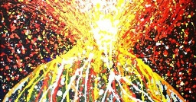 |  | Make a mark!  Paint – using a range of brushes.  Artist - Corey Barksdale, Jean Micheal Basquiat Francisco Goya.  Make tints of one colour by adding white.  Darken/lighten colours without using black/white  Demonstrate increasing control of the type of marks made to create certain effects.  Know how to use different paint brushes for different effects. E.g. small, flat headed.  Background wash range brushes different effects predict accuracy colour mis primary secondary colour wheel. 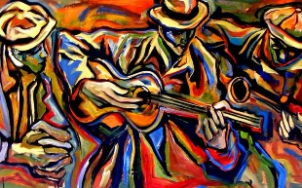 | Study of artists –  Know how to identify the techniques used by different artists.  Know how to compare the work of different artists.  Recognise when art is from different cultures.  The Sun Voyage by Jón Gunnar Arnason and Joseph Else, The lion on the council house.  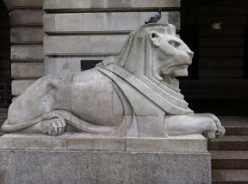  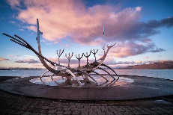 |  | Sculpture – Clay  Plan, shape, mould and make construction from clay.  Use tools to create shapes.  Show an awareness of how texture, form and shape can be transferred from 2D and 3D.  Consider and understand different aesthetics.  Create texture shape life size materials  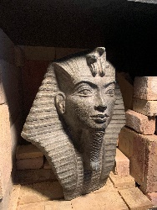
DT | Structures – castles |  | Mechanisms – pneumatic toys |  |  | Cooking and nutrition – eating seasonally.
RE | 3.1  Beliefs and questions  What difference does it make to be a Christian?  How do Christian people’s beliefs about God, Jesus, the world and others have impact on their lives?  Christianity | RE day- Focus on Christmas  Invite visitor  Focus- drama and art | 3.2  Religion, family and community: Prayer  How do religious families and communities practice their faith? Example of prayer  Christians and Muslims | 3.3  Worship and sacred places  Where, how and why do people worship?  Investigating places of worship in Nottinghamshire City and Nottingham  Muslims, Hindus, Christians  Visit to a Mosque |  | 3.4  Inspirational people from the past  What can learn from inspiring people in sacred texts and in the history of religions?  Religious leaders- Moses, Jesus and Muhammad.  Christians, Muslims and Jewish people, Sikhs and Humanism |  | RE day- Focus- Express yourself spiritually through the arts  Music, drama, art
PE | Competitive games  Cross country  Mind mile | Dance  Cross country  Mind mile | Gymnastics  Cross country  Mind mile | Competitive games  Cross country  Mind mile |  | Competitive games  Cross country  Mind mile |  | Athletics  Cross country  Mind mile
Music | Ukulele  play clear notes on instruments and use different elements in composition | Ukulele  combine different sounds to create a specific mood or feeling | Ukulele  create repeated patterns with different instruments  improve my work; explaining how it has been improved | Ukulele  use musical words to describe a piece of music and compositions  use musical words to describe what they like and do not like about a piece of music |  | Ukulele  recognise the work of at least one famous composer |  | Ukulele  recognise the work of at least one famous composer
Computing | Networks  INTERNET safety  Navigate the web to complete simple searches | Develop and create programs  Write programs that accomplish specific goals | Develop and create programs.  Design a sequence of instructions, including directional instructions | Algorithm’s  Discern when it is best to use technology and where it adds little or no value |  | Networks  navigate the web to complete simple searches
French | Basics 1  -Numbers up to 10  -Greetings  -Family members  -Pets  -Age | Basics 2  -Numbers up to 20  -Colours  -Days of the week  -Weather  -Christmas | The four friends  -Animals  -What I do in my spare time | Portraits  -Parts of the body  -Descriptions |  | Healthy living  -Healthy and unhealthy food  -Ordering in a café  -Sport |  | A trip to the beach  -Transport  -Travel  -Weather
Curriculum links with mathematics. | Science: Rocks  To interpret and present data using bar charts, pictograms and tables. When comparing and grouping different types of rocks.  Geography: Comparing Greece and the UK.  Map reading: recognise angles as a property of shape or a description of a turn.  Identify right angles, recognise that two right angles make a half-turn, three make three quarters of a turn and four a complete turn; identify whether angles are greater than or less than a right angle.  Identify horizontal and vertical lines and pairs of perpendicular and parallel lines. | Science: Animals including humans.  When recording exercise, compare durations of events [for example to calculate the time taken by particular events or tasks].  Estimate and read time with increasing accuracy to the nearest minute; record and compare time in terms of seconds, minutes and hours; use vocabulary such as o’clock, a.m./p.m., morning, afternoon, noon and midnight when talking about our diets.  When analysing nutritional labels: solve one-step and two-step questions [for example, ‘How many more?’ and ‘How many fewer?’] using information presented in scaled bar charts and pictograms and tables.  D.T. When designing and making clay necklaces: draw 2-D shapes and make 3-D shapes using modelling materials; recognise 3-D shapes in different orientations and describe them. | Science: Forces and Magnets.  When experimenting with magnets and testing pulleys -Recognise angles as a property of shape or a description of a turn.  Identify right angles, recognise that two right angles make a half-turn, three make three quarters of a turn and four a complete turn; identify whether angles are greater than or less than a right angle.  Identify horizontal and vertical lines and pairs of perpendicular and parallel lines.  History: The Stone Age, Bronze Age and Iron Age.  Timelines and sequencing  Working out how long ago or far apart events are/ were. Place value knowledge for sequencing. (Supported when reaching thousands). |  |  | Geography: Volcanoes and Earthquakes.  To measure, compare, add and subtract: volume/capacity (l/ml) when completing flooding fieldwork.  Working out how long ago or far apart events are/ were. Place value knowledge for sequencing e.g. natural disasters. (Supported when reaching thousands)  Place value knowledge when measuring Earthquakes using the Richter Scale.  Tell and write the time from an analogue clock (when measuring temperature and weather at the same time each day).  Science: Light and Shadows.  When measuring the length of shadows throughout the day:  Measure, compare, add and subtract: lengths (m/cm/mm).  Tell and write the time from an analogue clock and 12-hour and 24-hour clocks. | Science: Plants.  To interpret and present data using bar charts, pictograms and tables. When recording the results of investigations involving plants.  D.T.  To measure, compare, add and subtract: lengths (m/cm/mm); mass (kg/g); volume/capacity (l/ml). When making a healthy food product.  History: The Ancient Greeks.  Timelines and sequencing  Working out how long ago or far apart events are/ were. Place value knowledge for sequencing. (Supported when reaching thousands).  Comparing the Ancient Greek calendar to today. Recording events in a mock Olympic Games: Estimate and read time with increasing accuracy to the nearest minute; record and compare time in terms of seconds, minutes and hours; use vocabulary such as o’clock, a.m./p.m., morning, afternoon, noon and midnight. Know the number of seconds in a minute and the number of days in each month, year and leap year. Compare durations of events [for example to calculate the time taken by particular events or tasks].

