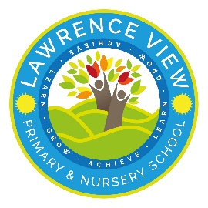
 | Autumn 1 | Autumn 2 | Spring 1 | Spring 2 | Summer1 | Summer 2
Quality Text  The Literacy Curriculum | The Man Who Walked Between Towers  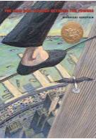  Robot Girl  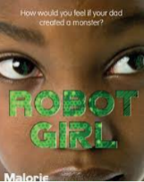 | The Tempest  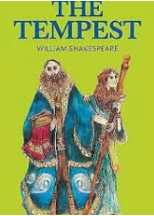  Percy Jackson  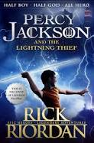 | The Lost Thing  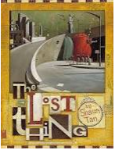  The Island  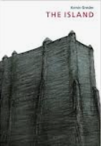 | The Sleeper and the Spindle  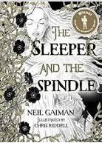  The Lost Happy Endings  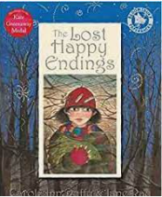 | Children of the Benin Kingdom  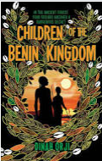  Otto, Autobiography of a Teddy Bear  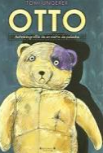 | High Rise Mystery  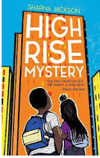  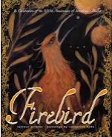  Firebird Saviour
Wow Starter | Take part in a carnival  Brazil Experience Day. | A simulated dig with children having to work out what certain artefacts would have been used for.
Enrichment |  | . | Kingswood or School outdoor learning experience.  Encounter exotic animals. | Space Centre visit  Learn to ride a bike safely (on road) (bikability) | Visit a working company  Halle orchestra- Play in an orchestra  Warburton’s Visit - Bake bread  Learn to sew  Participate in a school performance  Perform in a collective choir
Community links | Walk to the Salvation Army and donating items. | Local litter pick. | Visit recycling centre
School values | Curiosity | Resilience | Respect Kindness | Aspiration | Curiosity | Aspiration
British values | Respect the culture and beliefs of others  Democracy – student council/eco committee votes | Rule of law (Saxon laws- why etc)  Respect the culture and beliefs of others (RE) | Respect the culture and beliefs of others (RE, Topic) | Individual liberty  Respect the culture and beliefs of others (RE) | Democracy
Personal Development | Families and those who care for me. | Responsibility | Respectful relationships. Personal safety. | Safety in and around the home. | Community, First Aid, Democracy |  | Changing and growing (SRE)  Economic wellbeing
History key enquiry question and theme |  |  | British History-Anglo Saxons.  What were the effects of Anglo-Saxon and Scots’ settlement in Britain? |  | World History -Benin  How important is Eweka’s story?
- Key Knowledge |  |  | - Know how Britain changed between the end of the Roman occupation and 1066  - Know about how the Anglo-Saxons attempted to bring about law and order into the country  - Know that during the Anglo-Saxon period Britain was divided into many kingdoms  - Know that the way the kingdoms were divided led to the creation of some of our county boundaries today  - Use a time line to show when the Anglo-Saxons were in England  - Know about the Scots invasions from Ireland to North Britain.  History Skills  Place current study on time line in relation to other studies  • Know and sequence key events of time studied  • Use relevant terms and periods labels  • Relate current studies to previous studies  • Make comparisons between different times in history  • Compare accounts of events from different sources. Fact or fiction.  • Offer some reasons for different versions of events.  • Begin to identify primary and secondary sources.  • Use evidence to build up a picture of life in time studied select relevant sections of information.  • Confident use of library, e-learning, research  • Fit events into a display sorted by theme time.  • Use appropriate terms, matching dates to people and events.  • Record and communicate knowledge in different forms  - Work Independently and in groups showing initiative  Recovery from Y4  - Know about, and name, some of the advanced societies that were in the world around 3000 years ago  - Know how the Roman occupation of Britain helped to advance British society  - Place events from period studied on a time line  - Use terms related to the period and begin to date events.  - Understand more complex terms e.g. BCE/AD  - Begins to use evidence to build up a picture of a past event  - Asks and answers questions such as: What was it like for a.. during? |  | - Know some of the main events in Africa’s past.  - Know what caused Benin to lose its Bronzes  - Know why European sailors went to Benin  - Know why Eweka’s Benin with Saxon and Norman Britain are similar and different  - Know what is similar and different about Norman Britain and Eweka’s Africa.  Historical Skills  - Know how our knowledge of the past is constructed from a range of sources.  - Use a range of sources to find out about Africa’s past.  - Devise questions to identify what caused an event  - Make clear narratives across a period of study.  - Answer historical questions related to cause.  Make a comparison between Tudor Britain and Benin  - Address historically valid questions about similarity and difference  Recovery from Y4  - Know about, and name, some of the advanced societies that were in the world around 3000 years ago  - The achievements of the earliest civilizations
Geography Key Enquiry Question and themes | What are the impacts of urbanization in Brazil?  Geography Key Concepts: Place, space, scale, physical and human processes, cultural understanding and diversity. |  | Why should the rainforest be important to us all?  Geography Key Concepts: Place, space, scale, physical and human processes, interdependence, environmental interaction and sustainable development, cultural understanding and diversity.
Geography Key Knowledge. | - Know the names of, and locate, a number of South or North American countries  - Know key differences between living in the UK and in a country in either North or South America  - Know and locate some human and physical features in South America with a focus on Brazil.  - Know there are 12 countries in South America.  - Know that Brazil is the largest country in South America and covers almost half the continent. It is only slightly smaller than the USA.  - Know that South America’s largest river is the Amazon, which is the second longest river in the world. However, the Amazon carries more water than any other river in the world.  - Know about the reasons for urbanization in Brazil.  - Know that Sao Paulo is the largest city.  - Know that Spanish is the most popular language in South America even though Brazilians speak Portuguese.  - Know that Rio de Janeiro is famous for hosting the Rio Carnival each year.  - Know the difference between homes in Brazil and compare these to homes in Eastwood.  Geography Skills  - Use digital mapping to locate countries and describe features studied.  - Know how to use graphs to record features such as temperature or rainfall across the world.  - Use fieldwork to observe, measure, record and present the physical features in the local area (rainfall).  - Locate the USA and Canada on a world map and atlas.  - Locate and name the main countries of South America on a world map and atlas.  Recovery from Y4:  Know the names of and locate the seven continents of the world and locate these in an atlas.  -Know the names of and locate the five oceans of the world  - Know the names of the four countries that make up the UK and name the three main seas that surround the UK  -Know the name of and locate the four capital cities of England, Wales, Scotland and Northern Ireland  -Use the eight points of a compass (as in Y3) |  | - Know what is meant by biomes and what are the features of a specific biome.  - Know about climate zones across the world.  - Know the layers of the rainforest and how plants and animals are adapted to survive here.  - Know what deforestation is and the consequences that this has on people, the climate and animals.  - Know about sustainable solutions to protect the rainforest.  - Know about indigenous people that live in the rainforest.  - Know where the equator, Tropic of Cancer, Tropic of Capricorn, Northern Hemisphere, Southern Hemisphere are and know the relevance of lines of latitude to climate  - Know what is meant by the term ‘tropics’  -  Geography Skills  - Use digital mapping to locate countries and describe features studied  - Locate and name the main countries of South America on a world map and atlas.  - Use symbols and a key on maps  - Use maps and atlases to locate the Equator, Tropic of Cancer, Tropic of Capricorn and know the relevance of the lines of latitude.
Geography/History Fieldwork and Outdoor learning | Measuring rainfall in Eastwood and comparing to rainfall in an area of Brazil. Using measuring equipment accurately.  School grounds – Forest Schools. |  | How does deforestation in the Amazon Rainforest impact on our lives?  Creating ‘Forest Spirits’ out of natural materials to befriend and protect our school woodland.  Visit from the rainforest animal man.  Trip to Reuben Shaws Garden Centre to experience the warmth of a greenhouse.  Are there any signs of Anglo-Saxon culture in our wider local area? Trip
Science | Properties and changes in materials  - Compare and group materials based on their properties (e.g. hardness, solubility, transparency, conductivity, [electrical & thermal], and response to magnets – link to litter / waste/ recycling eco  - Know and explain how a material dissolves to form a solution  - Know and show how to recover a substance from a solution  Properties and changes in materials  - Know and demonstrate how some materials can be separated (e.g. through filtering, sieving and evaporating)  - Know and demonstrate that some changes are reversible and some are not  - Know how some changes result in the formation of a new material and that this is usually irreversible |  | Forces  - Know what gravity is and its impact on our lives  - Identify and know the effect of air and water resistance  - Identify and know the effect of friction  - Explain how levers, pulleys and gears allow a smaller force to have a greater effect  Space  - One million Earths could fit inside the sun – and the sun is considered an average-size star.  - An asteroid about the size of a car enters Earth’s atmosphere roughly once a year – but it burns up before it reaches us.  - The sunset on Mars appears blue.  - Earth is the third planet from the sun and the only world known to support an atmosphere with free oxygen, oceans of liquid water on the surface and life.  - There is no atmosphere in space, which means that sound has no medium or way to travel to be heard.  - Venus is the hottest planet in the solar system and has an average surface temperature of around 450° C  - The sheer size of space makes it impossible to accurately predict just how many stars we have. |  | All living things and their habitats  - Know the life cycle of different living things e.g. mammal, amphibian, insect and bird  - Know the differences between different life cycles – eco biodiversity  - Know the process of reproduction in plants  - Know the process of reproduction in animals  All living things and their habitats  - Know the life cycle of different living things -humans  - Know the process of reproduction in animal- Humans  Recovery from year 4  Classification – objectives need to be taught before Classification unit is started in year five  Recognise that living things can be grouped in a variety of ways.  Explore and use classification keys to help group, identify and name a variety of living things in their local and wider environment.  Plants topic not covered but has been taught in year 1 and 2. Objectives to be considered when life cycles is returned to in year five  Identify and describe the functions of different parts of flowering plants: roots, stem/trunk, leaves and flowers  Explore the requirements of plants for life and growth (air, light, water, nutrients from soil, and room to grow) and how they vary from plant to plant  Investigate the way in which water is transported within plants  Explore the part that flowers play in the life cycle of flowering plants, including pollination, seed formation and seed dispersal
Science | Recovery from year 4  Respecting our Environment – can be considered through class discussion/guided reading/homework  Identify where humans have had an impact on an environment  Identify ways that humans can damage an environment  Identify ways in which humans can protect and improve environments
Art | This is me  Mixed Media and Drawing  Artist- Fredia Karlo, Ed Fairburn, Barbra Kruger  Work in a sustained and independent way to create an accurate, detailed drawing.  Draw from different viewpoints considering the horizon line.  Begin to consider perspective.  Use different styles of shading work from a variety of sources including observation and photographs to develop work.  All sketching pencils  Pastels  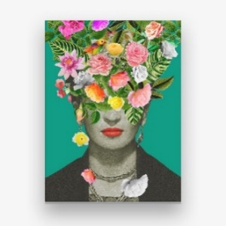  Pencil crayon |  | 5,4,3,2,1 Blast off  Colour  Poster paint / Powder paint.  Artist - Peter Thorpe, Ash Wheeler  Mix colours, shades, tones, tints with confidence, building upon previous knowledge.  Select colour for purpose explaining choices.  Discuss how colour can be used to express ideas, feeling and mood.  Confidently control the types of marks made and experiment with different effects and textures.  Powder paint  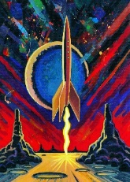 | Mood  Water colour  Artist - Lowry , MIES, own research.  Make and discuss hue, tint, tone, shade, and mood.  Discuss how colour can be used to express ideas, feeling and mood. Confidently control the types of marks made and experiment with different effects and textures.  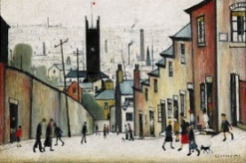  Water colour | Printing  Anna Nelson  Gain experience in overlaying colours.  Continue to experience in combining prints to produce an end print.  Demonstrate an awareness of printing onto fabric and consider the difference to printing onto paper.  Printing ink  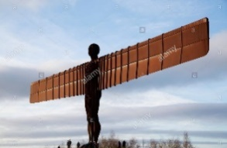  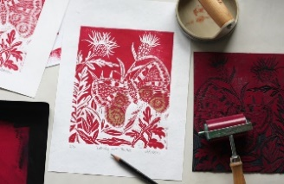 | Sculpture – Wire and recycled materials  Antony Gromley  Understand that a range of media can be selected (due to their properties for different purpose).  Independently recognise problems and adapt work when necessary- taking inspiration from other sculptors.  Wire and paper
DT | Structures – Bridges |  | Mechanisms – Pop up books. |  | Digital world – Monitoring devices
RE  Nottinghamshire Agreed Syllabus | 5.1  Inspirational people in today’s world  What can we learn from great leaders and inspiring examples in today’s world?  Islam, Hinduism and Christianity and a non religious example | RE day- Focus on Christmas  Invite visitor  Focus- drama and art | 5.2  Religion and the individual: what matters to Christians?  What is expected of a person in following a religion or belief? What matters most to Christians in their religion?  Christianity | 5.3  Beliefs and questions  How do people’s beliefs about God, the world and others have impact on their lives?  Islam, Hinduism, non religious worldviews such as Humanism  Trip to Buddhist temple | 5.4  Beliefs in action in the world  How are religious and spiritual thoughts and beliefs expressed in arts and architecture and in charity and generosity?  Christian, Muslim, Hindu. Non religious worldviews | RE day- Focus- Express yourself spiritually through the arts  Music, drama, art
ICT  icompute framework followed | Isafe  Becoming safe and responsible digital citizens | ialgorhythm  Unplugged Activities  -Searching, Sorting & Networks | Iweb  Remixing and creating web content using HTML | Icrypto  Introduction to cryptography | Iprogram  Designing and developing computer games | Iprogram  Designing and  developing multi level X Box game
French | Paris  -Facts about monuments  -Cultural facts  -Find a metro station on a map  -Items in a shop | Film/ TV  -TV programmes  -Film genres  -French pronouns | Clothing  -Names of clothes  -Say what someone is wearing  -Give opinion | Houses  -Rooms in a house  -Prepositions  -Furniture  -Easter | Places in a town  -Know the names of places in a town  -Prepositions  -Simple directions | At the café  -Food  -Drinks  -Dessert  -Opinions
Maths Links | Geography Brazil  Rainfall/temperature graphs  Creating venn diagrams  StatisticsMa5/4.1a solve comparison, sum and difference problems using information presented in a line graph  Science  Ma5/4.1b complete, read and interpret information in tables |  |  | History: The Saxons  Timelines and sequencing  Working out how long ago or far apart events are/ were. Place value knowledge for sequencing  Ma5/2.1a read, write, order and compare numbers to at least 1,000,000 and determine the value of each digit  Ma5/2.1b count forwards or backwards in steps of powers of 10 for any given number up to 1,000,000  Ma5/2.1c interpret negative numbers in context, count forwards and backwards with positive and negative whole numbers, including through 0  Science- Space and Forces  Planet information –distance from sun/size of planet etc  Ma5/4.1b complete, read and interpret information in tables  Ma5/2.1a read, write, order and compare numbers to at least 1,000,000 and determine the value of each digit  DT: Following  recipes, using ratio and proportion. Use scales to weigh accurately.  Converting cooking times. | History: Benin  History: The Saxons  Timelines and sequencing  Working out how long ago or far apart events are/ were. Place value knowledge for sequencing  Ma5/2.1a read, write, order and compare numbers to at least 1,000,000 and determine the value of each digit  Ma5/2.1b count forwards or backwards in steps of powers of 10 for any given number up to 1,000,000  Ma5/2.1c interpret negative numbers in context, count forwards and backwards with positive and negative whole numbers, including through 0  Dt Structures  Ma5/3.1a convert between different units of metric measure  measuring accurately using cm.mm  Ma5/3.2a identify 3-D shapes, including cubes and other cuboids, from 2-D representations  Ma5/3.2b know angles are measured in degrees: estimate and compare acute, obtuse and reflex angles | Science: life cycles.  Construct line graphs to show differences height of plants
PE | Invasion games  Cross country | Gymnastics and dance  Cross country | Invasion games  Cross country | Striking and fielding  Cross country  Cycling awareness | Striking and fielding  Cross country | Athletics  Cross country
Music | - maintain own part whilst others are performing their part  - describe, compare and evaluate music using musical vocabulary  - explain why they think music is successful or unsuccessful  - contrast the work of a famous composer with another and explain preferences  - compose music which meets specific criteria  - choose the most appropriate tempo for a piece of music

