

Lawrence View Primary and Nursery School
Play Policy

- Commitment
Our school undertakes to refer to this play policy in all decisions that affect children’s play. Our school is committed to providing the strategic and operational leadership needed to provide and maintain quality play provision for all of our children.

- Rationale
Our school believes that all children need opportunities to play that allow them to explore, manipulate, experience and affect their environment. We believe play provision should be welcoming and accessible to every child, irrespective of gender, sexual orientation, economic or social circumstances, ethnic or cultural background or origin, or individual abilities.

The OPAL Primary Programme rationale is that “… better, more active and creative playtimes can mean happier and healthier children, and having happier, healthier, more active children usually results in a more positive attitude to learning in school, with more effective classroom lessons, less staff time spent resolving unnecessary behavioural problems, fewer playtime accidents, happier staff and a healthier attitude to life.”

- Definition and value of play
Play is defined as a process that is intrinsically motivated, directed by the child and freely chosen by the child. Play has its own value and provides its own purpose. It may or may not involve equipment or other people.

We believe play has many benefits, including:

- Play is critical to children’s health and wellbeing, and essential for their physical, emotional, social, spiritual and intellectual development.
- Play enables children to explore the physical and social environment, as well as different concepts and ideas.
- Play enhances children’s self-esteem and their understanding of others through freely chosen social interactions, within peer groups, with individuals, and within groups of different ages, abilities, interests, genders, ethnicities and cultures.
- Play requires ongoing communication and negotiation skills, enabling children to develop a balance between their right to act freely and their responsibilities to others.
- Play enables children to experience a wide range of emotions and develop their ability to cope with these, including sadness and happiness, rejection and acceptance, frustration and achievement, boredom and fascination, fear and confidence.
- Play encourages self-confidence and the ability to make choices, problem solve and to be creative.
- Play maintains children’s openness to learning, develops their capabilities and allows them to push the boundaries of what they can achieve
- Aims
In relation to play our school aims to:

- Ensure play settings provide a varied, challenging and stimulating environment.
- Allow children to take risks and use a common-sense approach to the management of these risks and their benefits.
- Provide opportunities for children to develop their relationships with each other.
- Enable children to develop respect for their surroundings and each other.
- Aid children’s physical, emotional, social, spiritual and intellectual development.
- Provide a range of environments that will encourage children to explore and play imaginatively.
- Provide a range of environments that will support children’s learning across the curriculum and learning about the world around them.
- Promote independence and teamwork within children.
- Build emotional and physical resilience.

- Rights
Our school recognises the UN Convention on the Rights of the Child, which includes the right to play, recreation and leisure (Article 31) and the right of children to be listened to on matters important to them (Article 12). We acknowledge that we have a duty to take these rights seriously and listen to children’s views on their play.

- Benefit and risk
‘Play is great for children’s wellbeing and development. When planning and providing play opportunities, the goal is not to eliminate risk, but to weigh up the risks and benefits. No child will learn about risk if they are wrapped in cotton wool.’
Managing Risk in Play Provision: An Implementation Guide (Play Safety Forum, 2012)

The school will use the Health and Safety Executive guidance document Children’s Play and Leisure – Promoting a Balanced Approach (September 2012) as the principal value statement informing its approach to managing risk in play. In doing so, the school will adopt a risk-benefit approach as detailed in Managing Risk in Play Provision: An Implementation Guide (Play Safety Forum, 2012).

Risk-taking is an essential feature of play provision and of all environments in which children legitimately spend time at play. Play provision aims to offer children the chance to encounter acceptable risks as part of a stimulating, challenging and managed play environment. As outlined in the play sector publication ‘Best Play’, play provision should aim to ‘manage the balance between the need to offer risk and the need to keep children and young people safe from harm’.

In addition to standard risk-benefit assessments the school will practice dynamic risk management with children, encouraging them to identify and manage risks in an environment where adults are present to support them.
This approach to managing their own risk enables children to develop their resilience and perseverance, building positive self-esteem and self-awareness.

The full HSE Managing Risk Statement (Doc 4.6) is included as appendix 1 to this policy.

- Supervision
The law requires that children in school have supervision but for primary school playtimes there are no stated ratios. During the school day there should be one or more adults present outdoors. The school recognises OPAL’s three models of supervision: Direct, Remote and Ranging. Except for new children in reception, whose skills and orientation in the school environment need to be assessed, the school does not believe direct supervision is possible or beneficial. Supervisors will use ranging and remote supervision models, so that children can quickly find an adult and adults can patrol large sites to gain an awareness of the kinds of play and levels of risk likely to be emerging.

The school has identified play zones (see site map in appendix 2) which are each supervised by a member of the play team through a ranging approach. Where the school has identified play which poses additional risk, such as trampolines, we have allocated a member of staff to give direct supervision.

- The adult’s role in play
The school will help children maximise the benefits they can gain from play by the provision of trained staff who are informed by and work in accordance with the Playwork Principles. Staff will use and refer to these principles when appropriate interventions are needed, and ultimately will strive for facilitating an environment that nurtures children’s self-directed play.

The playworker’s core function is to create an environment that will stimulate children’s play and maximise their opportunities for a wide range of play experiences. A skilled and experienced playworker is capable of enriching the child’s play experience both in terms of the design and resources of the physical environment and in terms of the attitudes and culture fostered within the play setting. Playworkers are a channel of access to new materials and tools and they can act as a stimulus to children to explore and learn. They are also available to participate in the play if invited.

A copy of the Playworks Principles can be found in appendix 3

- Equality and diversity
Through providing a rich play offer meeting every child’s needs we will ensure all children, regardless of age, gender, race, disability or other special needs, can develop and thrive, build strong relationships and enjoy school.

- Environment
We believe that a rich play setting should ensure that all children have access to stimulating environments that are free from unacceptable or unnecessary risks and thereby offer children the opportunity to explore for themselves through their freely chosen play.

We will strive to continually improve the quality and diversity of our school’s grounds to enhance play. We will use the document ‘Best Play’ to guide us on what a quality play environment should contain. www.freeplaynetwork.org.uk/pubs/bestplay.pdf We also have access to the OPAL college resource to share examples of good practice.

Our extensive grounds and diverse range of equipment provide all children with opportunities to find their preferred play style. This rich play setting supports safeguarding, helps children develop confidence in team building and advocating for their own rights, increases children’s social and emotional capabilities and helps develop a love and enjoyment of the outdoors, which is a key foundation for caring for the environment.

Policy written by – Miss E. Stevenson June 2024
Next review June 2025

Appendix 1

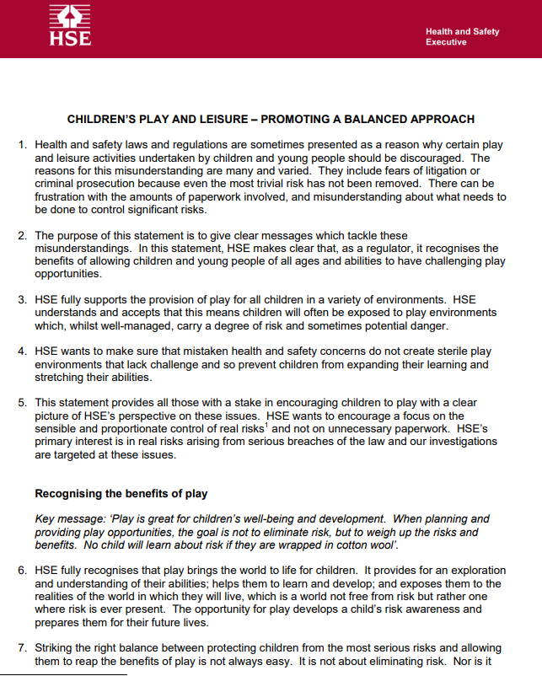

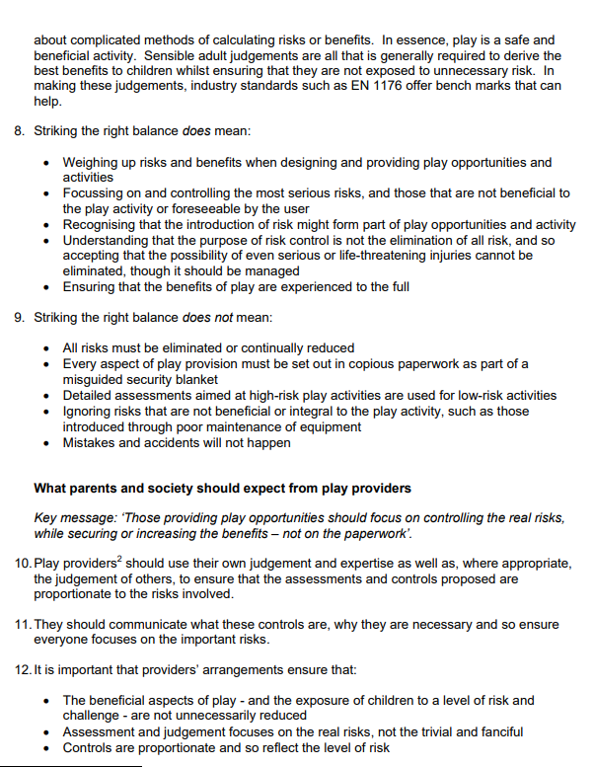

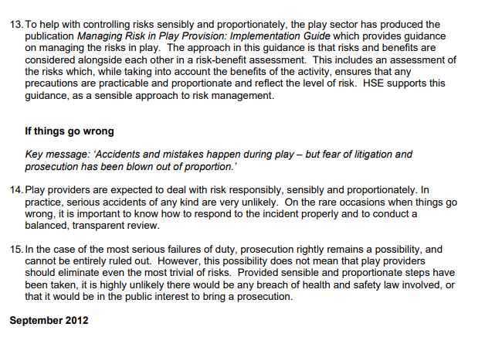

Appendix 2

Site map with highlighted play zones.

Appendix 3



