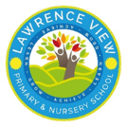 | Autumn 1 | Autumn 2 | Spring 1 |  | Spring 2 | Summer 1 |  |  | Summer 2
Quality Text  Literacy Curriculum | 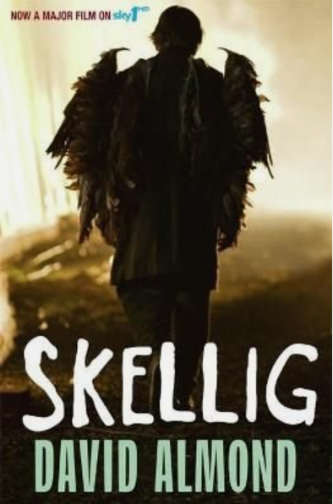Skellig  Audience: Class book  Purpose: To entertain  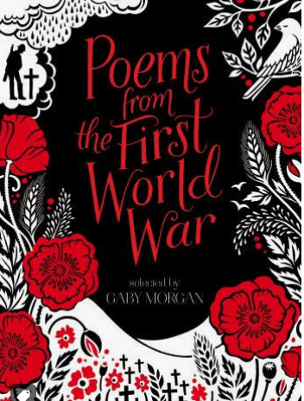  WW1 Poetry  Audience: Send to RBL  Purpose: To inform | Floodland  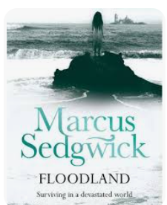  Audience: Class book  Purpose: To entertain  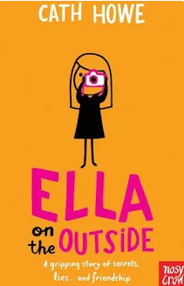  Ella on the Outside  Audience: Class book  Purpose: To entertain | 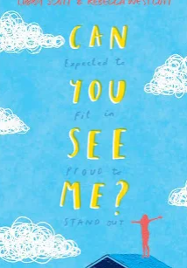  Can You See Me  Audience: Class book  Purpose: To entertain |  |   The Three Little Pigs  Audience: Class book  Purpose: To  inform/ To persuade  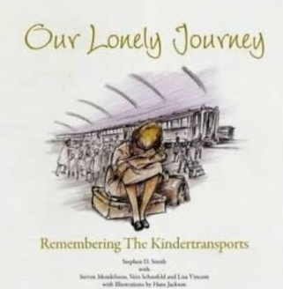  Our Lonely Journey  Audience: Class book/ send to Holocaust Centre  Purpose: To inform | 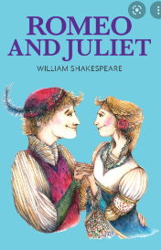  Romeo and Juliet  Audience: Class book  Purpose: To persuade  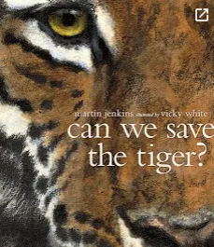  Can we save the tiger?  Audience: Class book  Purpose: To inform/persuade |  |  | 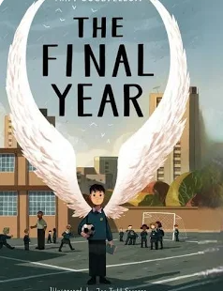  The Final Year  Audience: Class book  Purpose: To entertain
Enrichment | Use a map and compass  Independent navigation | Wellbeing garden project, Outdoor team challenges, Conservation work | Residential outdoor learning experience. |  | Holocaust Centre Visit  Environmental legacy project, | Raise money for charity  Run a small business.  Visit a theatre to watch a production
Geography Fieldwork and enrichment. | Can we use OS maps to navigate our way through the Peak District?  Trip to the Moorland Discovery Centre in the Longshaw Estate.  Peak District Explorers: Map Skills. |  |  |  |  | Should we support local more often?  Comparing prices in a local supermarket and a small independent business in Eastwood e.g. Annie’s Allotment.  Interview a local independent business to find out about their supply chain, prices, sustainability, impacts on trade e.g. covid pandemic.
Community links | DH Lawrence society-  Meet a politician | Invite a member of the community in to talk about Islam.  Local police visit  Adapting to changes in living circumstances- nomadic lifestyle possibly homeless charity/ immigrants | . Dare programme |  |  | Fair Trade Visit.
School values | Curiosity | Respect | Resilience/Kindness |  | Aspiration | Respect, curiosity, kindness, resilience, aspiration
British values | Democracy | Respect  Individual liberty (refugees) | Rule of the law  Mutual respect. |  | Tolerance | Rule of the Law
Personal Development | Families  Responsibility | Caring friendships | Respectful relationships Personal safety- not including relevant SRE aspects. |  | Safety in and  around the home  Drug education. | Community  First aid. | Alongside Science/Geography  Health and  Wellbeing  Community (environment)  Internet Safety |  |  | Ongoing  Mental Health  Sun Safety  Current affairs
Lead Enquiry Question and Themes | How will did the Anglo-Saxons and Vikings get on with each other?  Historical concepts: Evidence, Interpretations, Significance, Cause and Consequence |  |  |  |  | What was the impact of migration to Britain?  Historical concepts: Evidence, Interpretations, Significance, Cause and Consequence
History Key Knowledge | Know where the Vikings originated from and show this on a map  - Know that the Vikings and Anglo-Saxons were often in conflict  - Know why the Vikings frequently won battles with the Anglo-Saxons  - Know about the resistance from Alfred the Great and Athelstan.  - Have an understanding of Danegeld  Recap from Y5  - Know about how the Anglo-Saxons attempted to bring about law and order into the country  Know that during the Anglo-Saxon period Britain was divided into many kingdoms  Know that the way the kingdoms were divided led to the creation of some of our county boundaries today  Use a time line to show when the Anglo-Saxons were in England  Know about the Scots invasions from Ireland to North Britain.  History Skills:  Place current study on time line in relation to other studies. • Use relevant dates and terms • Sequence up to ten events on a time- line.  - Link sources and work out how conclusions were arrived at  - Consider ways of checking the accuracy of interpretations – fact or fiction and opinion.  - Be aware that different evidence will lead to different conclusions.  Confident use of the library etc. for research  Significant Individual – Edward the Confessor  - I know that the Anglo-Saxons and Vikings sometimes fought and sometimes lived peacefully, and can explain how this changed over time.  - I can compare the Anglo-Saxons and Vikings beliefs, housing, food and ways of life.  - I know how to place the Anglo-Saxons and Vikings on a timeline, and explain that they lived at the same time as other civilisations and after the Romans left Britain.  - I can discuss that Vikings first raided Britain but later settled, which caused big changes in language, place names, laws, and the way people lived.  - I can explain why Edward the Confessor was a significant king and how this shaped what happened next in British history.  - I can compare Viking achievements with other civilizations we have studied.  - I can explain how the impact of one event, can have many effects  - I can compare Viking Britain with civilisations I have studied previously, which existed concurrently, and explain why societies develop in different ways.  - Recognise primary and secondary sources.  - Use a range of sources to find out about an aspect of time past. Suggest omissions and the means of finding out.  Bring knowledge gathering from several sources together in a fluent account  - Select aspect of study to make a display.  - Use a variety of ways to communicate knowledge and understanding including extended writing.  Plan and carry out individual investigations |  |  |  |  | Know about a theme in British history which extends beyond 1066 and explain why this was important in relation to British history  - Know how to place historical events and people from the past societies and periods in a chronological framework  - know how Britain has had a major influence on the world  - Know about changes in an aspect of history, such as crime and punishment from the Anglo-Saxons to the present or leisure and entertainment in the 20th Century. (including how and why football changed across the 20th century in Britain and throughout the world (study - Arthur Whalton)  Recap from Y5  - Know why coal mining was important during the industrial revolution in Nottingham/Derby.  - Know what the industrial revolution was  - Know when the industrial revolution took place.  Skills:  - Place current study on time line in relation to other studies. • Use relevant dates and terms • Sequence up to ten events on a time- line.Link sources and work out how conclusions were arrived at  - Consider ways of checking the accuracy of interpretations – fact or fiction and opinion.  - Be aware that different evidence will lead to different conclusions.  Confident use of the library etc. for research  Black History link- Viv Anderson  - I know that people have migrated to Britain for thousands of years  - I know that migration can cause both continuity and change and can explain some of these.  - I can place key migrations on a timeline and explain how they link to earlier civilisations we have learned about.  - I know that migrants have shaped Britain’s society, housing, education and entertainment  - I know that migration has helped Britain become more diverse, and I can explain how different cultures have influenced our food, art, music, sports and inventions.  - I can explain how significant individual, ‘Viv Anderson’’s achievements helped change attitudes and challenge discrimination in Britain.  - ‘I know that different sources show different viewpoints about migration  - I can explain why some people may have supported or opposed migration at different times.  I can give reasons why Victorian Britian attracted migrants who worked in new industries, and that their contributions helped Britain grow during a time of huge change.  - Recognise primary and secondary sources.  - Use a range of sources to find out about an aspect of time past. Suggest omissions and the means of finding out.  Bring knowledge gathering from several sources together in a fluent account  - Select aspect of study to make a display.  - Use a variety of ways to communicate knowledge and understanding including extended writing.  Plan and carry out individual investigations
Geography Enquiry Question and themes | How does the landscape differ across the UK?  Geography Key Concepts: Place, space, scale, physical and human processes. |  |  |  |  | From farm to fork: How did trade get global?  Geography Key Concepts: Place, space, scale, physical and human processes, cultural understanding and diversity, interdependence, environmental interaction and sustainable development.
Geography Key knowledge | Name and locate counties and cities of the United Kingdom.  - Know the physical and human environments of The United Kingdom (UK), including key topographical features (including hills, mountains, coasts and rivers).  - Know about land use patterns in the UK and understand how some of these aspects have changed over time – Nottingham and Skegness case studies.  - Know how contour lines show variations in landscapes in the UK and identify these on OS maps.  - Know the names of and locate counties and at cities in England.  - Compare landscapes in the UK by knowing the main hills, mountain ranges, rivers and coasts in the UK.  - Identify the Peak District National park on a map of the UK. Explore land use and landscape in the Peak District e.g. hills, rivers, terrain type before going on the fieldwork trip. Know some of the peaks in the Peak District. Identify these on a map and notice the contour lines.  Geography Skills:  - Know what some ordnance symbols stand for and know how to use a key to find those that they do not recognise.  - Use OS maps, symbols and a key to answer questions.  - Know how to use six figure grid references.  - Explain scale and use maps with a range of scales.  - Compare landscapes using contour lines.  - Use digital mapping to locate countries and describe features studied.  - Use the eight points of a compass.  - Use fieldwork to observe, measure, record and present the human and physical features in the local area using a range of methods, including sketch maps, plans and graphs, and digital technologies.  Recap from Y4 and Y5:  Know the names of and locate the seven continents of the world and locate these in an atlas.  Know the names of and locate the five oceans of the world  Know the name of and locate the four capital cities of England, Wales, Scotland and Northern Ireland.  Know the names of the four countries that make up the UK and name the three main seas that surround the UK.  Know the highest mountains in the UK and identify these on a map.  Know the longest river in the UK (Severn) and identify on a map. Know the River Trent and the River Thames and identify these on a map.  Use OS maps with symbols and a key.  Use four-figure grid references and begin to use six figure grid references. |  |  |  |  | Know what trade is.  - Know the terms import and export.  - Know why industrial areas and ports are important.  - Understand the idea of global citizenship and Fairtrade  - Know why early settlements would develop near rivers.  - Know why seas, rivers and canals are important for trade links.  - Know main human and physical differences between developed and developing countries (distribution of natural resources, food, water, and energy).  - Know how trade can be impacted by political situations – focus on the Suez canal, the Ukraine crisis for food and gas shortages/prices, the COVID pandemic for a petrol crisis.  - Know the names of and locate at least eight major capital cities across the world.  - Know about time zones and work out differences  : Know about emigration to the UK and multiculturalism within the UK. Debate – how have migrants been received in the UK across history?  Identify examples of multiculturalism in Eastwood.  Geography Skills:  - Know what longitude and latitude are.  - Know what the Prime/Greenwich Meridian is and use this to explain how time zones work and work out differences in time across the globe (including day and night).  - Explain scale and use maps with a range of scales.  - Use digital mapping to locate countries and describe features studied.  - Use fieldwork to observe, measure, record and present the human and physical features in the local area using a range of methods, including sketch maps, plans and graphs, and digital technologies.  Recap:  - Know the names of and locate the seven continents of the world and locate these in an atlas.  - Know the names of and locate the five oceans of the world.  - Know about different climate zones in the world and that countries on the Equator and between the Tropic of Cancer and Capricorn are hot and wet all year round.
Science | Electricity  Electrical components  Simple circuits  Fuses and voltage  Compare and give reasons for why components work and do not work in a circuit  Draw circuit diagrams using correct symbols  Know how the number and voltage of cells in a circuit links to the brightness of a lamp or the volume of a buzzer  Working Scientifically:  systematically identifying the effect of changing one component at a time in a circuit; designing and making a set of traffic lights, a burglar alarm or some other useful circuit. Recap from year 5 Electricity – Recovery yr 4  Construct a simple series electrical circuit, identifying and naming its basic parts, including cells, wires, bulbs, switches and buzzers  Identify whether or not a lamp will light in a simple series circuit, based on whether or not the lamp is part of a complete loop with a battery  Recognise that a switch opens and closes a circuit and associate this with whether or not a lamp lights in a simple series circuit  Recognise some common conductors and insulators, | All living things and their habitats  Classification of living things and the reasons for it  Classify living things into broad groups according to observable characteristics and based on similarities and differences  Know how living things have been classified  Give reasons for classifying plants and animals in a specific way  Recap from yr5 Life cycles  Describe the differences in the life cycles of a mammal, an amphibian, an insect and a bird  Describe the life process of reproduction in some plants and animals | Evolution and Inheritance  Identical and non-identical off-spring  Fossil evidence and evolution  Adaptation and evolution  Know how the Earth and living things have changed over time  Know how fossils can be used to find out about the past  Know about reproduction and offspring (recognising that offspring normally vary and are not identical to their parents)  Know how animals and plants are adapted to suit their environment  Link adaptation over time to evolution  Know about evolution and can explain what it is |  | Animals, including humans  The circulatory system  Water transportation  Impact of exercise on body  Identify and name the main parts of the human circulatory system  Know the function of the heart, blood vessels and blood  Know the impact of diet, exercise, drugs and lifestyle on health  Know the ways in which nutrients and water are transported in animals, including humans | Light  - How light travels  - Reflection  - Ray models of light  - Know how light travels  - Know and demonstrate how we see objects  Know why shadows have the same shape as the object that casts them  Know how simple optical instruments work e.g. periscope, telescope, binoculars, mirror, magnifying glass etc.
Science | Recap year 5  Earth and Space – could be looked at through Guided Reading/Homework  Describe the movement of the Earth and other planets relative to the sun in the solar system  Describe the movement of the moon relative to the Earth  Describe the sun, Earth and moon as approximately spherical bodies  Use the idea of the Earth’s rotation to explain day and night and the apparent movement of the sun across the sky
Art | When I grow up I aspire to be …  Drawing – developing own style.  Augusto Constanzo  Select appropriate media and techniques to achieve a specific outcome.  Develop their own style.  Draw for a sustained period over several sessions.  Use tone in drawing to achieve depth.  Develop drawing with perspective and focal points.  All sketching pencils  Pastels  Charcoal  Pencil crayon  Pen    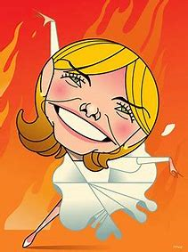 |  | Conflict  Mixed Media – Paint  Shamsia Hassani, Abu Malek al Shami, Banksy  Select colour to express feelings.  Discuss harmonious and contrasting colours and their placement on the colour wheel.  Work in a sustainable and independent way, developing own style.  Use colours and brushstrokes to create atmosphere and light effects.  Acrylic  Powder paint  Spray paint  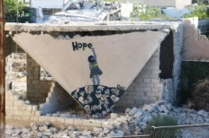  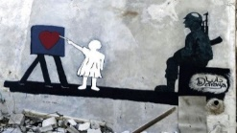 | Mixed Media and acrylic paint.  Blessing Ngobeni  Select colour to express feelings.  Work in a sustainable and independent way, developing own style.  Purposefully controlling the types of marks, brushstrokes used to create desired effects.  Use colours and brushstrokes to create atmosphere and light effects.  Acrylic  Powder paint  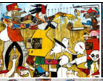 |  | Sculpture – Clay  Barbra Hepworth  Recognise sculptural forms in the environment and use these as inspiration for their own work.  Demonstrate experiences in relief and freestanding work using a range of media.  Independently select sculpture as a method of producing work, if this fits the criteria of the task.  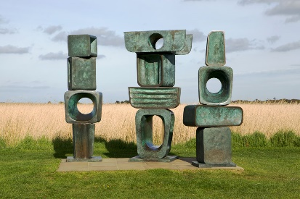  Clay
DT | Textiles – Stuffed decoration |  | Electrical systems – Steady hand games |  |  | Cooking and nutrition – come dine with me
RE  Nottinghamshire Agreed Syllabus | 6.1  Teachings, wisdom and authority  What can we learn by reflecting on words of wisdom from religions and worldviews? What do sacred texts and other sources say about God, the world and human life?  Hinduism, Buddhism and Christianity | RE day- Focus on Christmas  Invite visitor  Focus- drama and art | 6.2  Religion, worldviews, family and community  What contributions do religious make to local life in Nottingham City and Nottinghamshire a county of tolerance and respect? |  | 6.3  Beliefs in action in the world  How do religions and beliefs respond to global issues of human rights, fairness, social justice and the importance of environment?  Christianity, Hinduism and Humanism | 6.4  Beliefs in action in the world  What was the Kindertransport? Who resisted and rescued? How can we be upstanders today?  Judaism  Visit to the Holocaust centre |  |  | RE day- Focus- Express yourself spiritually through the arts  Music, drama, art
ICT  Purple Mash framework followed | E-Safety delivered throughout  Blogging  - Declarative – Children will know that  - Know what a blog is and its purpose.  - Know the features of an effective blog post.  - Know how layout improves readability.  - Know why reader engagement is important.  - Know how to stay safe and follow netiquette online.  Procedural – Children will know how to:  - Plan, draft, edit and publish a blog.  - Use hooks, headings, bullet points and conclusions effectively.  - Write in an engaging, conversational style.  - Respond appropriately to comments.  - Apply e-safety and moderate/report inappropriate content. | E-Safety delivered throughout  Networks  Declarative – Children will know that:  - Networks connect computers and devices.  - LAN and WAN are different types of networks.  - Networks require hardware such as routers and peripherals.  - Networks may be wired or wireless.  - The Internet and World Wide Web are different.  - Web browsers are used to access the web.  - Networks enable online communication.  - Filtering and censorship make parts of the internet less accessible for different reasons.  Procedural – Children will know how to:  - Identify local and global networks.  - Explain the difference between LAN and WAN.  - Create a simple network diagram.  - Identify Wi-Fi, mobile data and 5G as wireless connections.  - Describe the difference between the Internet and the World Wide Web.  - Use and identify web browser tools.  - Give examples of online communication and related safety tips.  - Explain why filtering and censorship are used. | E-Safety delivered throughout  Graphing  Declarative – Children will know that:  - Graphs help present and interpret data.  - Different graph types are used for different purposes.  - Bar charts compare data.  - Pie charts show parts of a whole.  - Line graphs show changes over time.  - Graphs should include clear titles, labels and scales.  - Graphs can be exported and used in other documents.  Procedural – Children will know how to:  - Create and interpret a range of graph types.  - Choose the most appropriate graph for a dataset.  - Produce comparative bar charts, pie charts and line graphs.  - Add appropriate titles, labels, keys and scales.  - Export and import graphs between applications.  - Analyse data and draw conclusions from graphs. |  | E-Safety delivered throughout  Data Detectives/ Coding  Declarative – Children will know that:  - Databases store and organise information.  - Databases contain tables, records and fields.  - Queries are used to search and retrieve information.  - Charts and graphs can be created from database data.  - Some databases use multiple linked tables.  - Multiple conditions can refine search results using AND/OR operators.  Procedural – Children will know how to:  - Identify tables, records, fields and data types.  - Use queries to search, filter, sort, group and calculate data.  - Create charts and graphs from database information.  - Link tables using common fields.  - Create queries across multiple tables.  - Use AND/OR operators to produce accurate search results.  Declarative – Children will know that:  - Cloning creates multiple objects within a program.  - Draggable objects and hotspots make programs interactive.  - Variables have different data types that affect how they work.  - User input can control how a program behaves.  - Flowcharts represent algorithms.  - Functions make code more efficient and reusable.  - Design documentation supports planning and debugging.  - Text-based adventure games use coding structures to create gameplay.  Procedural – Children will know how to:  - Use cloning, draggable objects and hotspots in programs.  - Create and use variables, data types and user input.  - Use sequences, selection, repetition and functions to build interactive programs.  - Interpret and create flowcharts.  - Plan, design and debug programs using design documentation.  - Read, adapt and improve the code for a text-based adventure game. | E-Safety delivered throughout  Modelling/Spreadsheets  Declarative – Children will know that:  - CAD (Computer Aided Design) is used to create accurate 2D and 3D designs.  - CAD is used in a range of industries.  - CAD allows designers to test, adapt and improve designs before they are made.  - 2Design and Make is a CAD program used to create 3D models.  - CAD models can be viewed from different perspectives.  - • CAD models can be viewed in Points, Net and 3D views.  - • Different viewpoints help designers improve their models.  - • Patterns and textures enhance the appearance of a design.  - • Editing points changes the shape of a 3D model.  - • A prototype is a first version used to test and improve a design.  Procedural – Children will know how to:  - Use 2Design and Make to create and adapt 3D models.  - Select appropriate templates and modify designs.  - Add textures and adjust model dimensions.  - Identify and correct design issues.  - View and evaluate models using different viewpoints (Points, Net and 3D).  - • View and edit models using Points, Net and 3D views.  - • Create and apply repeating patterns to a model.  - • Add, remove and move points to refine a design.  - • Evaluate and improve models before producing a final prototype.  Declarative – Children will know that:  - Spreadsheets organise and present data.  - Data is entered into cells using rows and columns.  - Formulae and functions automate calculations.  - Spreadsheets can model real-life situations.  - Data can be formatted, sorted and organised.  - Graphs and charts can be created from spreadsheet data.  - • Sorting and filtering help organise and analyse large datasets.  - • Filters temporarily hide data that does not meet selected criteria.  - • Spreadsheets can model real-life situations and solve problems.  - • Formulae make calculations efficient and update automatically when data changes.  Procedural – Children will know how to:  - Enter, edit and organise data in a spreadsheet.  - Use cell references, formulae and functions (e.g. SUM, AVERAGE, MIN, MAX).  - Format, sort and present data effectively.  - Use spreadsheets to solve real-life problems.  - Create and interpret a range of graphs and charts.  - • Sort data alphabetically and numerically.  - • Apply and clear text and number filters.  - • Use formulae to solve problems and model real-life scenarios.  - • Plan and manage information using a spreadsheet.  - • Apply spreadsheet skills to solve a range of data-handling problems. |  |  | E-Safety delivered throughout  Introduction to Python  Declarative – Children will know that:  - Python is a text-based programming language.  - Python has built-in and imported functions.  - Loops make programs more efficient.  - The range function controls repetition in loops.  - Python can perform mathematical calculations.  - Sprites can be programmed to move using coordinates.  Procedural – Children will know how to:  - Write simple Python programs using correct syntax.  - Use built-in functions such as print() and imported functions such as sleep().  - Create and use for loops and understand how they differ from while loops.  - Use the range() function to control repetition.  - Perform calculations using mathematical operators.  - Program sprites to move using coordinates.
French | School  -Names of school subjects  -Opinion phrases  -Masculine and feminine  -Everyday life in own culture and other cultures | Illnesses  -Body parts  -Medicines  -Names of common illnesses | Verbs  -Know there are 3 verb families  -French infinities and expressions  -New year resolutions |  | Hobbies  -Hobbies  -Opinions  -Weather conditions | Fristory  - Facts about Joan of Arc  -Louis XIV was and why he was important  - Causes and results of the French Revolution  - Napoleon Bonaparte |  |  | Spanish  -Greetings  -Age, name, where you live, nationality  -Colours  -Siblings  -Spanish culture
PE | Invasion Games  Cross country  Mindful Mile | Gymnastics and dance  Cross country  Mindful Mile | Invasion games  Cross country  Mindful Mile |  | Striking and fielding  Cross country  Mindful Mile | Striking and fielding  Cross country  Mindful Mile |  |  | Athletics  Cross country  Mindful Mile
Music  NCC Charanga programme | Happy | - Classroom Jaz | - A new Year Carol |  | Respect Rewind, Replay | School production |  |  | School production
Curriculum links with mathematics | - Geography: What makes the UK?  - Scales and measurement  Map reading, grid references and coordinates in 4 quadrants, knowing axis names and position (horizontal/vertical)  Scale and converting: convert miles to KM and vice versa, using scales to determine distance on maps. Measuring accurately in cm, mm and converting units.  Shape: identify/ draw nets and shapes to use in construction. Calculate area and perimeter of shapes.  Science: Animals including humans.  Convert units of time, seconds, minutes, when recording exercise.  Statistics calculate the mean as an average for pulse rate.  Use division to 2 dp to calculate average.  Art: Observational sketching  Perspective and scale factor when sketching.  Tessellation and translation in Viking art.  DT- Measuring, angles | Science: All living things and their habitats.  Construct pie charts to show differences in environments in living things. Show percentages of living things.  Art: Mixed media:  Using ratio to mix paints to create colours.  DT- Measuring, angles | History: The Vikings  Timelines and sequencing  Working out how long ago or far apart events are/ were. Place value knowledge for sequencing.  Following Viking recipes, using ratio and proportion. Use scales to weigh accurately.  Measurement: Construct a Viking Longboat, measure materials.  Statistics using pie charts/ constructing pie charts to compare immigration and emigration. Work out percentages of sectors.  Science: Evolution and inheritance:  Statistics, pie charts of inherited features in the class, averages as a mean of colour eyes, attached and non-attached ear lobes etc. Percentages of inherited features.  Measurement of plant leaves, fossils, conversion between units of measure.  DT- Digital world  Position and direction, Statistics and data handling |  | - Geography: What is fair?  Map reading, grid references and coordinates, knowing axis names and position (horizontal/vertical)  Scale and converting: convert miles to KM and vice versa, using scales to determine distance on maps. Measuring accurately in cm, mm and converting units.  Statistics using pie charts/ constructing pie charts to compare distribution of wealth/ comparing profit from bananas. Work out percentages of sectors.  Conversion charts/ line graphs time zones.  Science: Electricity:  Algebra, the power equation e.g. If a bulb generates 24 watts with a current of 2 amps flowing through it, what is the voltage across it?  Art: Sculpture  Perspective and scale factor when sketching, creating a sculpture.  Tessellation and translation to create pattern. Using ratio to mix paints to create colours  DT: Automata toys  Algebra, using equations of motion e.g A buggy moves along the ground for 20 seconds. Its initial velocity is 10m/s and its final velocity is 45m/s. What is its acceleration? | History: Leisure and entertainment  Timelines and sequencing  Working out how long ago or far apart events are/ were. Place value knowledge for sequencing.  League tables, negative numbers eg. Showing goal differences. Algebra, time/ speed / distance Olympic running times.  Science: Light  Perspective and scale factor with optical instruments.  Measurement and converting units e.g distance of objects, Sun to Earth.  Art: Sculpture  Perspective and scale factor when sketching, creating a sculpture.  Tessellation and translation to create pattern. Using ratio to mix paints to create colours  Styles of art, cubism drawing 3d shapes from different perspectives.  DT: create a dinner party, all 4 operations to help using budgeting skills.  Decimals to 3 dp to show money amounts and calculate prices. |  |  | History: Leisure and entertainment  Timelines and sequencing  Working out how long ago or far apart events are/ were. Place value knowledge for sequencing.  League tables, negative numbers eg. Showing goal differences. Algebra, time/ speed / distance Olympic running times.  Science: Light  Perspective and scale factor with optical instruments.  Measurement and converting units e.g distance of objects, Sun to Earth.  Art: Sculpture  Perspective and scale factor when sketching, creating a sculpture.  Tessellation and translation to create pattern. Using ratio to mix paints to create colours  Styles of art, cubism drawing 3d shapes from different perspectives.  DT: create a dinner party, all 4 operations to help using budgeting skills.  Decimals to 3 dp to show money amounts and calculate prices.

