Weekly story assembly to link with British Values and Protected Characteristics.
Spring Term- The order of these books may need altering to match the correct theme weeks.
Week | Music | Theme | Text
4 | Erasure Respect | Marriage and Civil Partnership  Individual Liberty  Mutual Respect | 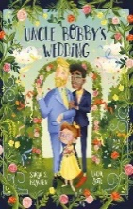
5 | ‘Home’ Micheal Bublé | Children’s mental health week | 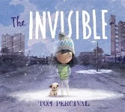
6 | Evelyn Glennie ‘Corelli’s La Folia’ | World hearing day  Disability | 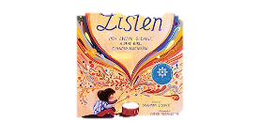
7 | ‘You can do whatever you want to do’  Cat Stevens | Gender Reassignment / Transgender Representation  Individual liberty  Mutual Respect | 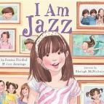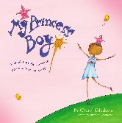
8 | ‘We are the world’  Chelsea Claydon and Robert Jerome. | Fair trade fortnight  Individual Liberty  Mutual Respect | 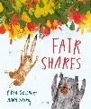
9 | EID songs for children | Eid 20/3/26  Religion or belief  Individual liberty | 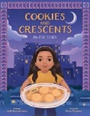
10 | Times they are a changing – Bob Dylan | Democracy | 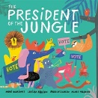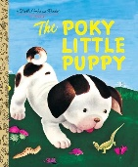
11 | Just The Way You Are -Bruno Mars | Individual liberty | 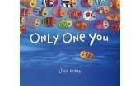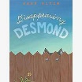
Summer Term- The order of these books may need altering to match the correct theme weeks.
1 | ‘Sealed Door’  Derek Paravincini | Autism Awareness month  Disability | 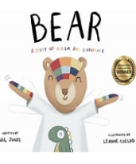
2 | ‘For the beauty of Earth’  Rutter | Earth Day 22/4/26  Mutal Respect  Rule of the Law  Gender and Disability | 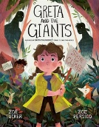
3 | ‘Nocturne in B Flat minor’  Beethoven | Autism awareness month  Albert Einstein  Disability | 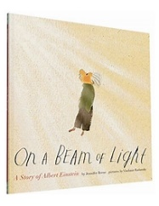
4 | ‘Walking on sunshine’  Katrina and the Waves | Mental Health Awareness month.  Disability | 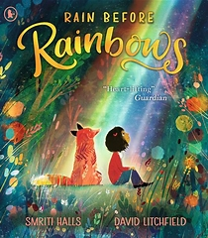
5 | ‘The carnival of animals’ | David Attenboroughs Birthday  Individual liberty  Mutual Respect | 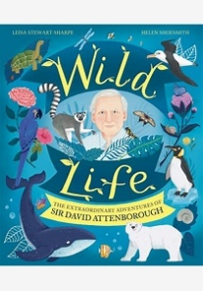
6 | ‘Yut gaaye’  Yamna Ajin | World day of cultural Diversity  Religion and Diversity | 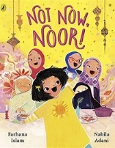
7 | ‘Memory’  Elaine Paige | Dementia awareness week  Age, Disability | 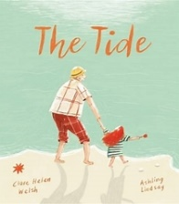
8 | ‘Save Trees’  Na Kaato Mujhe Dukhta Hai | World Environment day  Mutual Respect | 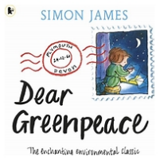
9 | ‘We are family’ Sister Sledge | Pride Month  Sexual Orientation  Tolerance  Mutual Respect  Individual Liberty | 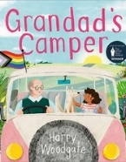
10 | ‘Volare’  Gypsy Kings | Gypsy, Roma, Traveler Month  Individual liberty.  Mutual Respect | 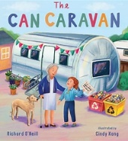
11 | ‘Build’  The house Martins | Women in Engineering  Individual liberty  Gender | 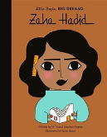
12 | ‘Baila Me’  Gypsy Kings | Gypsy, Roma, Traveler Month  Individual liberty  Mutual Respect | 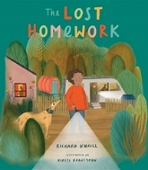
13 | ‘La Cucarache’ Mariachis | Frida Kahlo Birthday  Race | 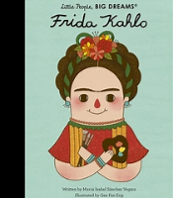
14 | ‘Free Nelson Mandela’ | Nelson Mandela International Day.  Race  Democracy  Individual Liberty | 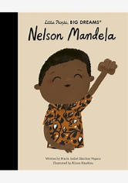
Autumn Term 1 and 2- The order of these books may need altering to match the correct theme weeks.
1 | Billy Withers a lovely day. | Community  Tolerance  Mutual respect | 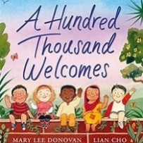
2 | Shum- Ukranian Folk song  Link for music | Immigration  Individual liberty | 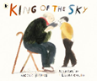
3 | Peace perfect peace- Hymn | International Peace Day  Mutual respect | 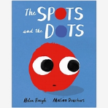
4 | Out in the country- By Cliff Richard | Mental Health Day | 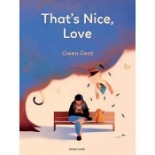
5 | Blossoms of a moonlit river in spring | Asia Heritage month  Race, Religion, tolerance | 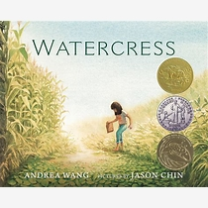
6 | Everyday people by Sly and the family Stone. Link for music | Refugees and immigration  Tolerance, individual liberty, Mutual Respect. | 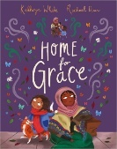
7 | Mad World by Garry Jules | Poverty  Mutual Respect | 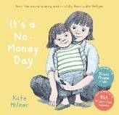
8 | Blue moon by Billy Holiday | Black History.  Individual liberty  Race | 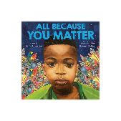
9 | Beat Boxing from Mad from Syria Link for music | Black History  Individual Liberty  Race | 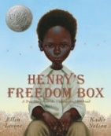
10 | The Kingston Trio- Where have all the flowers gone? | Remembrance Day  Individual Liberty | 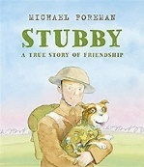
11 | Dipaawali Manaai  Schaani by Asha Bhosle | Diwali  Race and Religion  Individual Liberty | 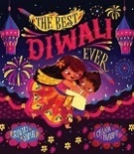
11 | Gareth Gates- Unchained melody | International Stammer day  Disability | 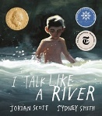
12 | Felz Navidad Vose Felciano | Disability Awareness week  Disability | 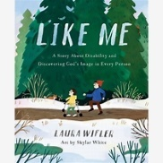
13 | Those were the nights of Chanukah- Yeshiva boys Choir | Hanukkah  Religion | 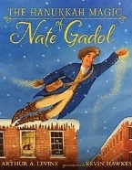
14 | Refugee by Steve Bell | Refugee  Mutual respect. Individual liberty. | 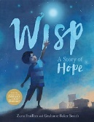
Spring Term 1
1 | Redemption song- Bob Marley (Marcus Garvey words) | It shows activism and the power of an individual voice in a community.  Democracy | 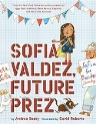
2 | Blossoms in the moonlit river in spring | Chinese new year  Race, Religion, Mutual Respect | 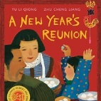
3 | Goodbye Odessa Yiddish Song | Holocaust Memorial  Individual Liberty, Mutual Respect, Rule of the Law  Race | 

