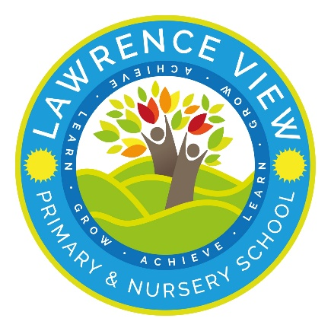
Child-on-Child Abuse Policy

Introduction
At Lawrence View Primary School we have a zero-tolerance approach to all forms of child on-child abuse including sexual violence, sexual harassment (SVSH) and harmful sexual behaviour (HSB). We believe that child-on-child abuse is never acceptable, and it will not be tolerated. It will never be passed off as “banter,” “just having a laugh,” or “a part of growing up”. We will respond to all signs, reports, and concerns of child-on-child abuse, including those that have happened outside of our school premises, and/or online. We recognise that children are vulnerable to and capable of abusing their peers, we take such abuse as seriously as abuse perpetrated by an adult. We recognise that even if there are no reports it does not mean it is not happening, it may be the case that it is just not being reported. We acknowledge that children who have allegedly abused their peers or displayed harmful sexual behaviour are themselves vulnerable. We are committed to a whole school approach to ensure the prevention, early identification, and appropriate management of child-on-child abuse within our school and beyond.
In cases where child-on-child abuse is suspected or identified we will follow our Child Protection procedures, taking a contextual, trauma-informed, and strengths-based approach to support all children who have been affected by the situation including the victim and alleged perpetrator.

Policy Development
This policy has been developed to reflect the most recent Keeping Children Safe in Education (KCSiE 2025) Statutory Guidance and was formulated in consultation with the whole school community with input from: the Senior Management Team (SMT), Senior Leaders, Behaviour Team and governors.
This policy is available:
- Online at https://www.greasleybeauvale.co.uk
- In the school prospectus
- From the school office
This policy is reviewed and evaluated throughout the academic year. It is updated annually.

Roles and Responsibilities
All staff working with children maintain an attitude of ‘it could happen here,’ and this is especially important when considering child-on-child abuse.
The Head teacher, has overall responsibility for the policy and its implementation and liaising with the Governing body, parents/carers, LA (Local Authority), and outside agencies.
Safeguarding is the responsibility of all however all staff, parents/carers and pupils need to be aware of who to report to and how to report any safeguarding concerns. The Designated
Safeguarding Lead (DSL) and their Deputies in our school is Emma McGrenaghan(HT), Emma Stevenson (AHT), Chris Blackburn (AHT)
The nominated Governor with responsibility for child-on-child abuse is Zoe Battison

Definitions
Child-on-child abuse is most likely to include, but may not limited to:
- Bullying (including cyberbullying, prejudiced-based and discriminatory bullying)
- Abuse in intimate personal relationships between children, (sometimes known as ‘teenage relationship abuse’)
- Physical abuse such as hitting, kicking, shaking, biting, hair pulling, or otherwise causing physical harm (this may include an online element which facilitates, threatens and/or encourages physical abuse)
- Sexual violence, such as rape, assault by penetration and sexual assault; (this may include an online element which facilitates, threatens and/or encourages sexual violence)
- Sexual harassment, such as sexual comments, remarks, jokes, and online sexual harassment, which may be standalone or part of a broader pattern of abuse
- Causing someone to engage in sexual activity without consent, such as forcing someone to strip, touch themselves sexually, or to engage in sexual activity with a third party
- Consensual and non-consensual sharing of nude or semi-nude images and/or videos (also known as sexting or youth produced sexual imagery)
- Upskirting, which typically involves taking a picture under a person’s clothing without their permission, with the intention of viewing their genitals or buttocks to obtain sexual gratification, or cause the victim humiliation, distress, or alarm
- Initiation/hazing type violence and rituals (this could include activities involving harassment, abuse, or humiliation used as a way of initiating a person into a group and may also include an online element). This may also be an indicator of wider exploitation such as Child Sexual Exploitation (CSE) and/or Child Criminal Exploitation (CCE) and/or County Lines.

Recognising
At Lawrence View Primary School we recognise that behaviours associated with child-on-child abuse take place on a spectrum. Understanding where a child’s behaviour falls on this spectrum is essential to being able to respond appropriately to it.
We recognise that all children grow and develop at their own pace. We will use our professional judgement and knowledge of child development when responding to child-on-child abuse.

Reporting and Responding
At Lawrence View Primary School we want children, parents/carers, staff, and visitors to confidently report abuse, knowing their concerns will be treated seriously. We recognise that our school’s initial response to a report of child-on-child abuse is incredibly important - how we respond to a report can encourage or undermine the confidence of future victims to report or come forward. As a school we will also respond to reports of alleged child-on-child abuse that have occurred online or outside of school. These reports will be treated seriously, and the school remains committed to supporting and safeguarding all parties including the victim, alleged perpetrator, and any other child(ren) who may be affected.
We will make decisions on a case-by-case basis, with the Designated Safeguarding Lead (or a deputy) taking the leading role and using their professional judgement, supported by other agencies, such as the Local Authority, Children’s Social Care, and the Police as appropriate. We will ensure that we reference and follow other school policies and procedures as appropriate.
We have clear reporting systems for each group of our school community, the effectiveness of these reporting systems is reviewed throughout the academic year and may be expanded to meet the needs of all members of our community.

Children (including bystanders)
It is important to understand that a victim may not find it easy to tell staff about their abuse verbally. Children can show signs or act in ways that they hope adults will notice and react to. In some cases, the victim may not make a direct report. We recognise that in some instances another child may report on another child’s behalf. All children will know how to report concerns or incidents of child-on-child abuse.
We ask that all children report any concerning behaviour to a member of school staff – this can be any member of teaching or non-teaching staff, including a class teacher, a TA, the Head teacher, a lunchtime supervisor, or a member of the office team. We talk about trusted adults regularly in class and in assemblies to remind our children of who they can report concerns to.
The member of staff will listen to the child and make an initial note of their concerns, they will then discuss next steps with them and reassure them that they will be supported. In line with the statutory guidance provided in Keeping Children Safe in Education 2023, we will never promise a child that we will not tell anyone about a report of any form of abuse, as this may not be in the best interests of the child. The member of staff will make a formal record of the concern/report on the school’s recording system (CPOMs.) and other relevant members of staff will be alerted. The member of staff will directly alert the school’s Designated Safeguarding Lead if the report is deemed urgent or if a child is considered at risk.
We understand that some children may find it difficult to tell a member of staff about their concerns verbally, we therefore have additional reporting mechanisms in place.

Parents/carers
We understand that parents and carers may well struggle to cope with making or receiving a report that their child has been the victim of or is an alleged perpetrator of child-on-child abuse.
In line with the statutory guidance provided in Keeping Children Safe in Education 2025, we will seek advice and support from other services as decided on a case-by-case basis. All decisions and actions taken by the school will consider the needs of the individual children involved, and the wider school community.
We ask that if parents/carers have concerns about their child experiencing or allegedly perpetrating child-on-child abuse, that they contact the school’s Designated Safeguarding Lead/Deputy (in person/via telephone call/via email) to explain their concerns. The Designated Safeguarding Lead/Deputy will take an initial note of the concerns but may ask to schedule a meeting to allow for more time to discuss the concerns in detail. Following the report and/or the meeting, the Designated Safeguarding Lead/Deputy will make a formal record of the report on the school’s recording system (CPOMs) and other relevant members of staff will be alerted. The Designated Safeguarding Lead/Deputy will seek advice from Statutory Services if the report is deemed urgent or if a pupil is considered at risk.
We ask that parents/carers come directly to the school with their concerns rather than discussing them with other members of the school community in person or online.
Our school remains committed to supporting pupils and their families in all instances of child-onchild abuse. We will endeavour to ensure that all parties are kept informed of progress and any developments, but we will also need to show due regard to GDPR (General Data Protection Regulations) and ongoing investigations by statutory services. This may mean, at times, that we are not able to provide or share information or updates.
If a parent/carer is not satisfied with our school’s actions, we ask that they follow our school’s complaint policy and procedures. This is available online from our school website and on request from the school office.

Staff
Our staff work closely with our children and therefore may notice a change in a child’s behaviour or attitude that might indicate that something is wrong before receiving a report from a child or a member of the school community. If staff have any concerns about a child’s welfare or are concerned that a child is displaying behaviours that may show they have been the victim of or that they are perpetrating child-on-child abuse, they should act on them immediately rather than wait to be told.
We ask that staff report their concerns to a Designated Safeguarding Lead/directly to the Head teacher. The member of staff receiving the report will take an initial note of the concerns and will then make a formal record of the report on the school’s recording system (CPOMs) and other relevant staff members will be alerted. The Designated Safeguarding Lead/Deputy will seek advice from Statutory Services if the report is deemed urgent or if a pupil is considered at risk.

Visitors
We ensure that all visitors to our school are aware of our Child Protection and Safeguarding procedures and which staff member they should report any concerns to (the member of staff may differ depending on the purpose of the visit e.g., supply teacher, governor, external agency etc.).
We ask that if a visitor to our school has any concerns about child-on-child abuse that they have witnessed, or have been told about, that they report their concerns at the earliest opportunity in person to the school’s Designated Safeguarding Lead/the Head teacher/a member of the Senior Leadership Team. We ask that visitors report their concerns in person by the end of the school day. For example, it would not be appropriate to wait until the following day or leave a written note with concerns. The member of staff receiving the report will take an initial note of the concerns and will then make a formal record of the concerns on the school’s recording system (CPOMs/My Concern etc.) and other relevant staff members will be alerted. The Designated Safeguarding Lead/Deputy will seek advice from Statutory Services if the report is deemed urgent or if a child is considered at risk.

Recording and evaluating
We will ensure a written report is made and uploaded to CPOMS as soon after the disclosure as possible recording the facts as presented by the child. These may be used as part of a statutory assessment if the case is escalated. We will ensure the Designated Safeguarding Lead (or deputy) will be informed as soon as possible, if they were not involved in the initial report. We will ensure that details of decisions made and reasons for decisions are recorded as well as any outcomes.
We will ensure that any ‘safety plans’ are recorded electronically and uploaded to CPOMS and kept under review.

Strategies for Prevention
Our school, Lawrence View Primary School, actively seeks to raise awareness of and prevent all forms of child-on-child abuse by:
- Staff training – o Contextual safeguarding
  - Identification and classification of specific behaviours – SVSH, HSB etc o Making it clear there is a zero-tolerance approach to child-on-child abuse
(especially in relation to SVSH) that it is never acceptable and will not be tolerated. Ensuring it is never passed off as “banter,” “just having a laugh,” or “a part of growing up”.
  - Recognising, acknowledging, and understanding the scale of harassment and abuse and that even if there are no reports it does not mean it is not happening, it may be the case that it is just not being reported
  - Challenging physical behaviours (potentially criminal in nature) such as grabbing bottoms, breasts, and genitalia, pulling down trousers, flicking bras and lifting up skirts
  - Challenging the attitudes that underlie such abuse (both inside and outside of the classroom)
  - Responsibilities of the Governing body / proprietors / management committee – they must be aware of their statutory safeguarding responsibilities (effective child protection policy – child-on-child abuse policy)
  - Ensuring that all child-on-child abuse issues are fed back to the safeguarding lead/team so that they can spot and address any concerning trends and identify those children who may need additional support
- Information for children (pupils/students) - o Creating an ethos and culture in which all children feel able to share their concerns openly, in a non-judgemental environment, and have them listened to
  - All children are frequently told what to do if they witness or experience any form of child-on-child abuse, the effect that it can have on those who experience it and the possible reasons for it. This is included are a regular part of our PSHE lessons. o They are regularly informed about the school’s approach to all forms of child-onchild abuse, including the school’s zero-tolerance approach towards all forms of child-on-child abuse, the process for reporting their concerns of child-on-child abuse and where to go for further help, support, and advice
  - Educating all children about the nature and prevalence of child-on-child abuse via a well embedded RHE/RSHE curriculum, PSHE curriculum or wider curriculum
  - Challenging the attitudes that underlie such abuse (both inside and outside of the classroom)
- Information for parents/carers - o Talking to parents, both in groups and one-to-one
  - Providing opportunities for parents to be involved in the review of school policies and lesson plans; and
  - Encouraging parents to hold the school to account on this issue o Asking parents what they perceive to be the risks facing their child and how they would like to see the school address those risks
  - Challenging the attitudes that underlie child-on-child abuse – in school and/or the wider community
  - Ensuring parents /carers are aware of the ethos and culture of the school or college
- RHE (Relationships and Health Education) / RSHE curriculum - o The school have a clear set of values and standards, upheld, and demonstrated throughout all aspects of school life, which is supported by a planned programme of evidence based RSHE curriculum
  - Our RHE/RSHE/PSHE programme is fully inclusive and developed to be age and stage of development appropriate (especially when considering children with SEND
(Special Educational Needs and Disabilities) and/or other vulnerabilities) o We will, through our RHE/RSHE/PSHE programme promote:
    - Healthy and respectful relationships
    - Boundaries and consent
    - Equality and raise awareness of stereotyping and prejudice
    - Body confidence and self-esteem
    - How to recognise an abusive relationship, including coercive and controlling behaviour
    - The concepts of, and laws relating to – sexual consent, sexual exploitation, abuse, grooming, coercion, harassment, rape, teenage relationship abuse (intimate personal relationships between children), and how to access support, and
    - What constitutes sexual harassment and sexual violence and why these are always unacceptable

Breaches / Complaints
Breaches to this policy will be dealt with in the same way that breaches of other school policies are dealt with, as determined by the Head teacher and Governing Body.
If a parent/carer is not satisfied with our school’s actions, we ask that they follow our school’s complaint policy and procedures. This is available online from our school website, and on request from the school office.

Links with other policies
You may find it helpful to read this child-on-child abuse policy alongside the other following school policies:
Policy | How it may link
Safeguarding Policy | Includes information about child protection procedures and contextualised safeguarding
Behaviour and Relationships Policy | Includes details about the school’s behaviour system including potential sanctions for pupils
Anti-Bullying policy | Includes information about bullying behaviours and vulnerable groups
Online Safety / E-Safety / Acceptable Use Policies | Includes information about children’s online behaviour and details about online bullying/cyberbullying
Equalities Policy | Includes information about our school’s approach to tackling prejudice and celebrating differences. Links to prejudice-related language and crime and the protected characteristics
RSHE / PSHE Policy | Includes information about our school’s RSHE programme and how we teach about healthy relationships, friendships, and bullying
Complaints Policy | Includes information about how to make a complaint if you are not satisfied with the school’s response

Monitoring and Review
This policy is reviewed and evaluated throughout the academic year. It is updated annually.
Date approved by the Governing Body: November 2026
Date to be reviewed: Autumn 2028

Appendix 1
Simon Hackett (2010) has proposed a continuum model to demonstrate the range of sexual behaviours presented by children and young people, from those that are normal, to those that are highly deviant:

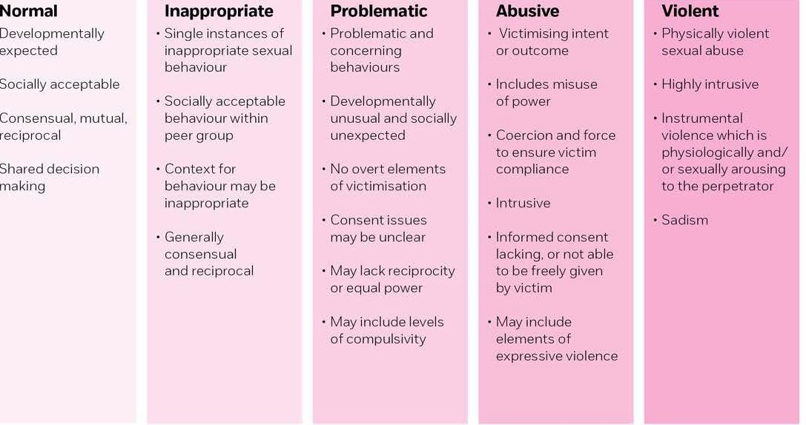

https://www.nspcc.org.uk/globalassets/documents/publications/harmful-sexual-behaviourframework.pdf

Appendix 2
Support for Young People: Local and National
- Nottinghamshire Children and Young People’s Independent Sexual Violence Advisors (ChiIVAs) provided by IMARA provide emotional and practical support for victims of sexual violence. They are based within the specialist sexual violence sector and will help the victim understand what their options are and how the criminal justice process works if they have reported or are considering reporting to the police. ChISVAs will work in partnership with schools and colleges to ensure the best possible outcomes for the victim.
www.imara.org.uk/about us/chisva-service
- Child and adolescent mental health services (CAMHS) www.nottinghamshirehealthcare.nhs.uk/camhs https://www.nottinghamshirehealthcare.nhs.uk/camhs
- Rape Crisis Centre's can provide therapeutic support for children over 13 who have experienced sexual violence.
www.nottsssvss.org.uk
- Internet Watch Foundation (to potentially remove illegal images) www.iwf.org.uk

• Appendix 3
Further information and support can be found through the following links:
- Part 5: Child-on-child sexual violence and sexual harassment (pages 105-135) of Keeping Children Safe in Education (2023) Keeping children safe in education 2023 (publishing.service.gov.uk)
- Definitions - Keeping children safe in education 2023 (publishing.service.gov.uk)
- Simon Hackett (2010) Continuum model of sexual behaviours - o Sexual development and behaviour in children | NSPCC Learning
o NSPCC Learning Understanding sexualised behaviour in children | NSPCC Learning
- Government Publications
- Sexual harassment and sexual violence in schools
- www.gov.uk/government/publications/sexual-violence-and-sexual-harassment-betweenchildren-in-schools-and-colleges
- Preventing youth violence and gang involvement
- www.gov.uk/government/publications/advice-to-schools-and-colleges-on-gangs-and-youthviolence
- Preventing and tackling bullying in schools
- www.gov.uk/government/publications/preventing-and-tackling-bullying
- Ofsted – Review of sexual abuse in schools and colleges June 2021
- www.gov.uk/government/publications/review-of-sexual-abuse-in-schools-and-colleges • Other useful documents
- Sexting
- Sharing nudes and semi-nudes: advice for education settings working with children and young people December 2020
- www.gov.uk/government/publications/sharing-nudes-and-semi-nudes-advice-for-educationsettings-working-with-children-and-young-people/sharing-nudes-and-semi-nudes-advicefor-education-settings-working-with-children-and-young-people
- Farrer & Co - Peer-on-peer abuse toolkit, guidance on peer-on peer abuse policy and template peer-on-peer abuse policy
- www.farrer.co.uk/Global/Peer-on-peer%20abuse%20toolkit%2014.pdf
- Anti-bullying Alliance
- Sexual Bullying: Developing Effective Anti-bullying Practice
- A guide for school staff and other professionals
- https://antibullyingalliance.org.uk/sites/default/files/uploads/attachments/Sexual%20bullying%20-
%20antibullying%20guidance%20for%20teachers%20and%20other%20professionals%20%20FINAL_0_0.pdf
- Preventing abuse among children and young people-guidance from Stop it Now
- What is Age appropriate?
- http://www.stopitnow.org/ohc-content/what-is-age-appropriate
- NSPCC-Harmful sexual behaviour
- https://www.nspcc.org.uk/preventing-abuse/child-abuse-and-neglect/harmful-sexualbehaviour/
- NCB Harmful sexual behaviour
- https://www.ncb.org.uk/resources-publications/resources/workforce-perspectives-harmfulsexual-behaviour
- NSPCC –Is this sexual abuse?
- https://www.nspcc.org.uk/globalassets/documents/research-reports/nspcc-helplines-reportpeer-sexual-abuse.pdf
- Online sexual harassment
- Project deSHAME- Digital Exploitation and Sexual Harassment Amongst Minors in Europe Understanding, Preventing, Responding
- https://www.childnet.com/our-projects/project-deshame
- Sexism
- It’s Just Everywhere- a study on sexism in schools –and how we tackle it
- https://ukfeminista.org.uk/wp-content/uploads/20/12/Report-Its-just-everywhere.pdf

