
Prevent Policy

Introduction
At Lawrence View Primary and nursery School we recognise the importance of safeguarding against susceptibilities including radicalisation and recognise that pupils can be susceptible to extremist ideology and radicalisation. We are committed to promoting the welfare of pupils, whilst protecting them from this risk as part of our safeguarding responsibilities.
We recognise the multi-cultural, multi-faith nature of the United Kingdom and understand the crucial role our school plays in promoting these values through our school values and curriculum. We support and adhere to guidance from the DfE which requires schools to actively promote fundamental British values to enable pupils to challenge extremist views and ensure that pupils are encouraged to regard people of all faiths, races and cultures with respect and tolerance.

Our commitment to safeguarding pupils against extremism, radicalisation and terrorism beyond our curriculum can include interventions and collaboration with other agencies, including the police and the Local Authority where appropriate and as required.

This ‘Prevent Policy’ is part of our commitment to keeping children safe in our school community.

Aims
The Government's objectives of Prevent are to:
- tackle the ideological causes of terrorism
- intervene early to support people susceptible to radicalisation
- enable people who have already engaged in terrorism to disengage and rehabilitate
The overall aim of their counter-terrorism strategy is to reduce the risk from terrorism to the UK, its citizens and interests overseas, so that people can go about their lives freely and with confidence. Prevent remains one of the key pillars of CONTEST, alongside the other ‘P’ work strands:
- Prevent: to stop people becoming terrorists or supporting terrorism
- Pursue: to stop terrorist attacks
- Protect: to strengthen our protection against a terrorist attack
- Prepare: to mitigate the impact of a terrorist attack More information can be found using the following link:
https://www.gov.uk/guidance/get-help-if-youre-worried-about-someone-being-radicalised
At Lawrence View Primary and Nursery School, the main aims of our policy are to ensure that staff are fully engaged in being vigilant about radicalisation; that they overcome any potential misgivings that such issues will not happen here and ensure that we work alongside other professional bodies and agencies to ensure that our pupils are safe from harm. Ensuring Lawrence View Primary and nursery school exercises its due regard to the need to prevent people from being drawn into terrorism. The principal objectives are that:

- All Staff and Governors will complete appropriate training to develop and maintain an up to date understanding of what radicalisation and extremism are and why we need to be vigilant in school.
- All Staff and Governors will know that Lawrence View Primary School has a policy on anti-radicalisation and extremism and will follow the policy when issues arise.
- All parents and pupils will know that Lawrence View Primary School has policies in place to keep pupils safe from harm and that the school regularly reviews its systems to ensure they are appropriate and effective.

Child Protection and Safeguarding
We understand that protecting children from the risk of radicalisation is part of the school’s wider safeguarding duties and is similar in nature to protecting children from other harms, whether these come from within their family or are the product of outside influences.

Key Values
All staff are expected to uphold and promote the fundamental principles of British values, explicitly promoted since 2014, including democracy, the rule of law, individual liberty and mutual respect, and tolerance of those with different faiths and beliefs. The intention is to give our children the skills to build resilience and therefore protect them from any extremist views they may encounter, now or later in their lives. Moreover, by promoting fundamental British values through our school vision, aims and values, our school aims to enable pupils to better challenge extremist views.
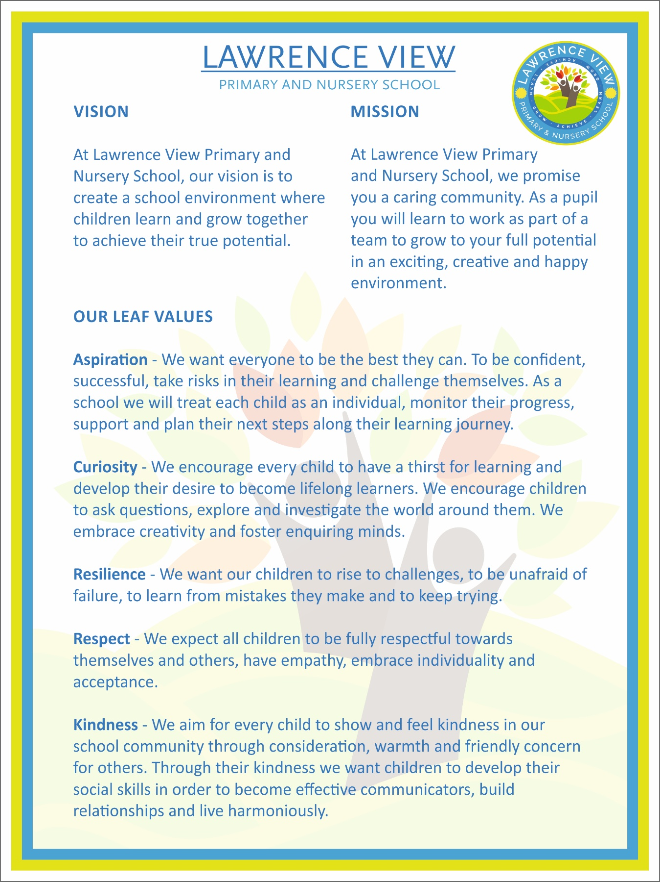

The Role of Our Curriculum
Our vision, aims and values are at the core of everything we do. They underpin our curriculum and provide an environment which prepares our pupils for the next stages in their lives. We are committed to ensuring that our pupils are offered a broad and balanced curriculum that builds upon their cultural capital and aims to prepare them for life in modern Britain.

Children are encouraged to share their views and recognise that they are entitled to have their own different beliefs which should not be used to influence others. A range of different religious and cultural festivals will be celebrated across the year giving every pupil the opportunity to take part.

Children are regularly taught about how to stay safe when using the Internet and are encouraged to recognise that people are not always who they say they are online. They are taught to seek adult help if they are upset or concerned about anything they read or see on the Internet. Appropriate filtering and monitoring systems will be installed to protect children from terrorist and extremist material online, in accordance with the Online Safety Policy.

Our school provides a safe space in which children and staff can understand the risks associated with terrorism and develop the knowledge and skills to be able to challenge extremist arguments. Our school will ensure that any discussions around radicalisation and extremism are suitable for the age and maturity of the children involved.

Our PSHE Curriculum:
In Reception, the EYFS framework is used to purposefully assist staff in developing children’s personal, social and emotional development and their understanding of the world.

The topics develop skills and knowledge around areas such as internet safety; build character traits such as resilience, determination, self-esteem and confidence; and promote of fundamental British Values such as respect, responsibility, participation and contribution to society and tolerance.

Definitions and Indicators

What is radicalisation?
Radicalisation refers to the process by which a person comes to support terrorism and forms of extremism leading to terrorism. During that process it is possible to intervene to prevent vulnerable people being drawn into terrorist-related activity.

What is extremism?
Vocal or active opposition to fundamental British values, including democracy, the rule of law, individual liberty and mutual respect and tolerance of different faiths and beliefs. Please note that being drawn into terrorism includes not only violent extremism but also non-violent extremism. Extremism can take several forms, including Islamist extremism, far-right and animal rights extremism for example.

What is terrorism?
Is defined as violent threats or actions designed to influence government or intimidate the public with the purpose of advancing a political, religious or ideological cause. This includes endangering or causing serious violence to a person or people, serious damage to property, and seriously interfering or disrupting an electronic system.

Roles and Responsibilities

The Headteacher is Responsible for:
- The overall implementation and management of this policy and staff training.
- Ensuring every staff member is familiar with the scope of this policy.
- Ensuring pupils are taught about British values through the curriculum.
- Ensuring the school is a safe space in which pupils can understand and discuss sensitive topics, including terrorism and extremism, and are able to challenge these ideas.
- Undertaking a risk assessment to determine whether pupils are at risk of being drawn into terrorism.
- Identifying extremist risks in the local area.
- Ensuring any visitors and speakers at the school are appropriate and vetted prior to them having access to pupils.

The Designated Safeguarding Leads are Responsible for:
- Handling any referrals to the Channel programme and supporting staff who make referrals to Channel.
- Following up any referrals made to the Channel programme.
- Provide advice and support to staff on protecting pupils from the risk of radicalisation.
- Delivering staff training on the Prevent duty.
- Working with external agencies to support pupils at risk of being drawn into terrorism.
- Providing guidance to other staff members to help them support pupils at risk of being drawn into terrorism.
- Understanding local procedures for making a Prevent referral and making Prevent referrals where appropriate.
- Considering if it would be appropriate to share any information with a new school or college in advance of a pupil leaving, e.g. if the pupil is currently receiving support through the ‘Channel’ programme and the information would allow the new setting to have support in place for when the pupil arrives.

All Staff Members are Responsible for:
- Being alert to the risk factors of extremism and radicalisation and any changes in a pupil’s behaviour which could indicate that they may need help or protection.
- Raising any concerns with the Designated Safeguarding Leads.
- Notifying the Designated Safeguarding Leads when they make any referrals to the Channel programme.
- Engaging in staff training on the Prevent duty.
- Using their professional judgement to identify pupils who may be at risk of radicalisation and acting proportionately.

Safeguarding from Extremism
The school protects the right to freedom of expression. This policy is not intended or designed to restrict or prevent legitimate and lawful congregation or debate. The school has a dedicated DSL who deals with any incidents of extremism and/or terrorism within our school community. As is the school’s responsibility under law, we will do our utmost to safeguard our pupils from being drawn into extremism and terrorism.

The school has strong relationships with our local safeguarding partners and will involve them at the earliest opportunity if safeguarding issues arise. The school encourages any pupil, parent, staff member or member of the wider school community to speak to the DSL if they have concerns about:

- Pupils becoming radicalised.
- Groups, clubs or societies with extremist or radical views.
- Friends and/or families of pupils becoming radicalised or involved in extremism.
- Pupils planning to visit known areas of conflict.
- Members of the school and wider community attempting to draw young and/or vulnerable pupils into extremism.
Visitors and speakers coming into the school will be vetted prior to them having access to pupils.

‘Channel’ and ‘Prevent’
Channel, a key element of the Home Office’s Prevent strategy, is a multi-agency approach to protect people at risk from radicalisation. The school will work with the LA, local law enforcement, and religious and community leaders, to identify children vulnerable to radicalisation and to challenge extremism if it arises.
The school will cooperate with local panels involved in the Channel process. A representative of the school will attend meetings as required to aid the mitigation of identified risk and vulnerabilities. This includes contributing towards the support plan and sharing information necessary and proportionate to the effective working of the panel.

Potential Signs of Radicalisation and Extremism
There are no known definitive indicators that a young person is vulnerable to radicalisation, but there are number of signs that together increase the risk.

Early indicators of susceptibility may include (but not limited to):
- Being in possession of extremist literature.
- Graffiti, artwork or writing that displays extremist themes.
- Attempts to impose extremist views or practices on others.
- Online searches, comments or profiles related to extremism.
- Having family or friends involved in extremism.
- Appearing susceptible to being influenced or controlled by a group.
- Displaying a radical desire for political or moral change.
- Showing sympathy for extremist causes.
- Intolerance of difference, including faith, culture, gender, race or sexuality.
- Searching for identity, meaning and belonging or feeling under threat.
- Sudden, unexpected or out of character religious conversion.
- Displaying feelings of grievance, injustice or underachievement.
- Experienced or witnessed traumatic events on global, national or local scale.
- Rejection, exclusion or conflict within the family, social or faith groups.
- Secretive or unexplained changes in behaviour or dress.

Training
New staff will undergo prevent training as part of the induction process. All staff will undergo 3 yearly Prevent awareness training, to ensure that they can recognise the indicators of radicalisation and how to respond. Staff, including the DSL and any deputies, will also undergo regular training in response to any local or national updates.

Assessing Risk and Procedures for Referrals in School
Although serious incidents involving radicalisation have not occurred at Lawrence View Primary and Nursery School to date, it is important to be constantly vigilant and remain fully informed about the issues which affect the region in which we teach. If any member of staff has any concerns about a pupil, they will raise this with the DSL or Deputy DSLs.

Parents will be contacted to discuss the issue and investigate where there are any mitigating home circumstances, unless doing so would put the pupil at further risk of harm.

The Governing Body, Head Teacher and Deputy Designated Safeguarding Leads will assess the level of risk within the school and put actions in place to reduce that risk. Risk assessment may include consideration of the school’s curriculum, key policies, the use of school premises by external agencies or visitors, integration of current and future pupils, anti-bullying policy and other issues specific to the school’s profile, community and philosophy.

We believe that it is possible to intervene to protect people who are vulnerable. Early intervention is vital, and staff must be aware of the established processes for front line professionals to refer concerns about individuals and/or groups. We must have the confidence to challenge, the confidence to intervene and ensure that we have strong safeguarding practices based on the most up-to-date guidance and best practice.

Allegations and concerns of radicalisation and/or terrorism will always be taken seriously and the Head Teacher as Designated Lead for Child Protection and Safeguarding, as well as the Deputy and Assistant Head, will deal swiftly with any referrals made by staff or with concerns reported to them by staff.

The school recognises that pupils’ parents and families are best placed to spot signs of radicalisation and, as such, will promote effective engagement with parents and families.

The Safeguarding Leads will discuss the most appropriate course of action on a case-bycase basis and will decide when a referral to external agencies is needed.

Making a judgement
When assessing whether a pupil is at risk of radicalisation, the following questions could be considered:
- Does the pupil have access to extremist influences through the internet?
- Does the pupil possess or actively seek extremist material?
- Does the pupil sympathise with, or support, extremist groups or behaviour in their speech or written work?
- Does the pupil’s demeanour suggest a new social, religious or political influence,
e.g. through jewellery or clothing?
- Has the pupil previously been a victim of discrimination or a religious crime?
- Has the pupil experienced any major disagreements with their peers, family or faith groups, leading to rejection, isolation or exclusion?
- Does the pupil display an irregular and distorted view of religion or politics?
- Does the pupil display a strong objection towards specific cultures, faiths or race? • Is the pupil a foreign national awaiting a decision regarding deportation or immigration?
- Is there an irregular pattern of travel within the pupil’s family?
- Has the pupil witnessed or suffered from trauma or violence in a war zone or through sectarian conflict?
- Is there evidence of a relative or family friend displaying extremist views?
- Has the pupil travelled for extended periods of time to international locations?
- Does the pupil have experience of poverty, disadvantage, discrimination or social exclusion?
- Does the pupil display a lack of affinity or understanding for others?
- Is the pupil a victim of social isolation?
- Does the pupil have insecure, conflicted or absent family relationships?

Critical indicators include where a pupil is:
- In contact with extremist recruiters.
- Articulating support for extremist causes or leaders.
- Accessing extremist websites.
- In possession of extremist literature.
- Using extremist narratives and a global ideology to explain personal disadvantage.
- Justifying the use of violence to solve societal issues.
- Joining extremist organisations.
- Making significant changes to their appearance and/or behaviour.

Making a Referral
Information from the Nottinghamshire County Council can be found using the following link: https://www.nottinghamshire.gov.uk/business-community/prevent-duty

Where the school has growing concerns that intervention at school level is insufficient or is concerned that a young person might become actively involved in violent extremism (including promoting or supporting it as well as through direct violent actions) it will refer via the Prevent referral form (found using the link above) or over the phone (Telephone: 101 ext. 800 2962/2963). Initial conversations can also be had with the Nottinghamshire Police Prevent Team over the phone where useful.

In most cases, the DSL will refer the case to the Channel programme where there is a radicalisation concern, as appropriate. Any staff members may make referrals to the Channel programme if they deem it necessary – the DSL will be notified in all cases and will support staff members who do so. Staff members will be informed that they may be asked to attend a Channel panel to discuss the pupil who has been referred to determine whether support is required. The LA’s Channel panel will decide which support, if any, is required and arrange for this support to be implemented.

The DSL will follow up any referrals and the pupil will be monitored for a period to determine whether there have been any changes in behaviour. Parents will be consulted during this period, unless doing so would put the pupil at further risk of harm.
If any further concerns are raised, the DSL will contact the Channel programme to discuss further steps.

Where the school’s view is that there needs to be involvement from Social Care, for example, where there is concern that a young person/ parent may be planning to go abroad to support extremism, referrals will also be directed to the Multi Agency Safeguarding Hub (MASH).

If the school has concerns around extremism or radicalisation regarding an adult (teacher, TA, governor, parent, older sibling, visitor, temporary staff or any adult of concern), these referrals should be made directly to the Police Prevent Team. They can be contacted directly on 101 Ext 800 2962/2963.

The DSL will record and retain all incidents for school records in accordance with the Data Protection Act 2018 and the UK GDPR, as outlined in the Data Protection Policy.

See the link below for how information will be stored and shared through Channel:
https://www.gov.uk/government/publications/channel-data-privacy-notice/channel-dataprivacy-information-notice

PREVENT ACTION PLAN
Date: February 2025
Next Review: February 2026

Leadership & Management
Objective: Ensure the leadership team understands and implements the Prevent Duty effectively.
Action | Responsibili ty | Timeline | Success Criteria
Designate a new Prevent  Lead | Headteacher | Immediate | Named person identified in policies.
Ensure Prevent Duty is embedded within Safeguarding and Child Protection Policies. | DSL /  Safeguarding  Team | Termly  Review | Policy updated and accessible.
Conduct Prevent Risk Assessment annually. | DSL / SMT | Annually | Risk assessment completed and actions implemented.

Staff Training & Awareness
Objective: Ensure all staff can identify concerns and act appropriately.
Action | Responsibili ty | Timeline | Success Criteria
Provide Prevent training for all staff (including spotting signs of radicalisation). | DSL /  Training Lead | 2-3 years | Training logs and staff confidence.
Induction training for new staff covering Prevent Duty. | HT/DSL | Ongoing | All new staff trained.
Ensure staff understand local risks, such as far-right extremism or online radicalisation. | DSL | Ongoing | Staff can identify key risks.

Curriculum & British Values
Objective: Embed British values and critical thinking into the curriculum.
Action | Responsibili ty | Timeline | Success Criteria
Ensure British Values (democracy, rule of law, individual liberty, mutual respect & tolerance) are embedded in the curriculum. | BV  Lead/Curricul um Lead | Termly  Monitoring | Evidence in planning and lessons.
Teach critical thinking and online safety to protect pupils from extremist narratives. | Computing /  PSHE Lead | Ongoing | Pupils demonstrate understanding.
Promote diversity and respect for different faiths and backgrounds (linked to  Equality Policy and objectives) | Class  Teachers/PSH E Lead/RE lead | Ongoing | School displays and curriculum reflect inclusion.

Safeguarding & Reporting Procedures
Objective: Ensure concerns are reported and addressed appropriately.
Action | Responsibili ty | Timeline | Success Criteria
Ensure a clear reporting procedure for Prevent-related concerns. | DSL/HT | Ongoing | Staff understand referral process.
Maintain Prevent referral records, monitoring trends and taking action. | DSL /  HT/Govs | Termly  Review | Safeguarding logs up to date.
Work with external agencies (LA Prevent Lead, Police, Social Services). | DSL | Ongoing | Effective partnerships in place.

Parental & Community Engagement
Objective: Build a strong relationship with parents and the wider community.
Action | Responsibilit y | Timeline | Success Criteria
Communicate Prevent Duty responsibilities with parents via | HT/SMT/Leads where required | Annually | Parents understand Prevent Duty.
newsletters, website & meetings.
Provide workshops or guidance on online safety and radicalisation risks. | DSL /  Computing  Lead | Annually | Parents engage in discussions.
Engage with local faith and community groups to promote inclusivity. | SMT /  Governors | Ongoing | Strong community relationships.

Monitoring & Evaluation
Objective: Regularly assess the effectiveness of the Prevent strategy.
Action | Responsibilit y | Timeline | Success Criteria
Conduct termly Prevent audits and report findings to governors. | DSL / HT | Termly | Minutes & reports reflect action taken.
Review curriculum impact on promoting British Values. | Curriculum  Lead / BV Lead | Annually | Pupils demonstrate understanding.
Keep up to date with national and local Prevent updates. | DSL | Ongoing | School is compliant with statutory requirements.

This policy takes due regard of relevant legislation and statutory guidance including, but not limited to, the following:

- Children Act 1989
- Education Act 1996
- Counter-Terrorism and Security Act 2015
- Childcare Act 2006
- Data Protection Act 2018
- UK GDPR

This policy also reflects statutory and non-statutory departmental advice, including, but not limited to, the following:

- Prevent Strategy (2011)
- DfE (2021) ‘The Prevent duty’
- HM Government (2021) ‘Revised Prevent Duty Guidance: for England and Wales’
- ‘Keeping children safe in education 2024’ (KCSIE)
- DfE (2023) ‘Working Together to Safeguard Children’
- Home Office (2021) ‘Channel Duty guidance: protecting people vulnerable to being drawn into terrorism’
- Promoting fundamental British values as part of SMSC in schools: Departmental advice for maintained schools (DfE 2014)

This policy also operates in conjunction with the following school policies and documents:

- Child Protection and Safeguarding Policy
- Data Protection Policy
- Online Safety Policy
- Equality Information and Objectives Policy and statement

