Lawrence View Primary and Nursery School
“Learn, Grow, Achieve”
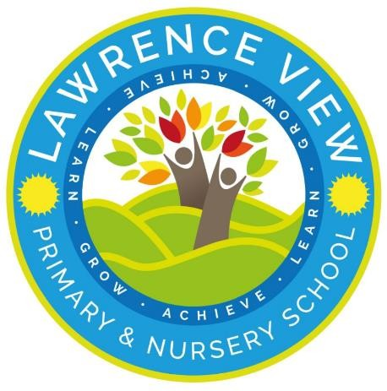

Parent Helper Guidelines
In the Classroom and on Educational Visits out of School
September 2026

Thank you for volunteering to help our children in school. We feel that the involvement of parents in children’s education is vital, and we encourage active participation in many ways.
Some parents come to school to help with variety of tasks such as reading support, ICT and cooking and usually work with individual or small groups from specific classes. Other parents help when the children are taken on visits outside school.

The aim of this document is to give you all the information you need to make your time both worthwhile and enjoyable. Thank you for all your support.
We aim to: -
- Provide a rich and balanced curriculum, encouraging creativity and promoting high standers, so that children can learn successfully.
- Value individuality, promote respect and provide equal opportunities for all.
- Encourage children to respect and value themselves and others.
- Acknowledge the solid learning foundation from children’s early years and help them to develop with growing independence and confidence.
- Develop positive partnership with families and the wider community.
- Encourage children to take responsibility for themselves and others and for their learning and their environment.
- Create an environment for which is welcoming, secure, supportive and fun and where all achievements are valued.
Parent helpers have a valuable role in helping us to fulfil these aims and values.
The following are brief guidelines regarding the undertaking of the role of volunteer helper in school.

Signing policy
We ask that you read and sign two copies of these guidelines. Please keep one copy for your information and leave one at school for the Parent Helper Co-Ordinator.

Parent Helper Guidelines

  - Disclosure. There is a requirement for school to carry out Disclosure and Barring service check for all staff and volunteers who have regular contact with children. All schools need to hold a register of the check undertaken. In order for you to work regularly in school as a volunteer, you will need to complete a DBS form (available from the school office). Please be assured that all information will be treated in the strictest confidence and that these checks are done only for the protection and safety of other children.
  - Confidentiality. It is very important that all staff, parent volunteers and other adults working in the school adhere to our policy of professionalism and confidentiality. You may see children struggling with work, being upset or, misbehaving or hear/see other information concerning a child while you are with us in school. It is vital that you do not share anything about specific children with friends, family or a child’s parents, even if you know them well. Please discuss any issues that you may come across with the class teacher. It is the teacher’s responsibility to inform parents of any concerns about their child.
  - Volunteers working in classrooms should do so on the understanding that they support the teaching staff. This may mean working with groups or individuals outside or inside the classroom/ these groups may not include your own child.
  - When the class teacher is leading lessons and activities, volunteers should behave appropriately e.g not talking to other adults or children or fiddling with objects etc. Your behaviour should mirror that of the class teacher.
  - Please do not have ‘favourites’- as humans we are drawn to certain individuals but is important that all children in school are given equal time and attention.
  - Please encourage the children to be independent- we expect children to try everything themselves before we help them.
  - Do not lift, carry or move a child in any way.
  - If a child does something or tells you something that causes you concern, please tell the class teacher or headteacher/The designated safeguarding lead as soon as possible in an appropriate setting, respecting confidentiality.
  - Please keep your mobile phone switched off during your time helping at school and on trips.
  - Parent helpers may not take photographs/ record videos in school and must not use their devices.

Guidance for volunteers on educational visits out of school
These guidance notes have been written in conjunction with the school’s policy on off-site visits. If you have any questions about a school educational visit, please see the class teacher. We appreciate your help on such visits- it would be difficult to organise visits outside school without parent volunteers.
- Parent helpers must be at the pre-visit briefing/risk assessment meeting immediately before departure.
- Parents may not always have their own child in their group.
- The teacher will give permission helpers a list of children whom they are responsible.
- All children are told that they must stay with their group and the group adult at all times.
- If the visits involve a coach journey, please help the children in your group to put on and fit their seatbelts. Children are not allowed to eat and drink on the coaches. The class teacher has sick buckets/bags, if needed.
- Adults must sit spread out through the length of the coach, not together.
- The class teacher is responsible for ALL first aid and medication.
- The class teacher leads the rules, routines and expectations for the day. Please help the teacher by ensuring that your group follows all instructions e.g., when to eat and drink.
- Parents are not aloud to take children to the toilet.
- With older children (juniors) a parent may wait outside the toilet while the children go as a group or at least in pairs. With younger children (infants) a staff member must accompany the children. Never go into the toilet yourself while the children are in there, unless a member of staff is present.
- If there is a medical or other emergency, let the class teacher know immediately. The class teacher is responsible for contacting the school and associated parent in an emergency situation.
- Please keep your mobile phone switched off during educational visit.
- Please do not give/buy children food items or treats, during the school visit.
- No photographs or videos may be taken (including with a phone) on a school visit.
- If you need to leave your group for any reason, please inform the class teacher.
- Parent volunteers are asked you keep the same degree of confidentiality as in school. If you have any observations or queries concerning your visit, please direct these to the class teacher.

Please see Quick reference sheet in appendix 1 for the key principles.

Thank you for your help and your co-operation. Your support makes it possible for us to undertake many interesting activated with the children.

Name _________________

Signature _________________


Lawrence View Primary and Nursery School
“Learn, Grow, Achieve”
Quick reference guide for Parent Helpers on Educational visits
Role of the volunteer helper:
- To be remain with and be responsible for all of the children in your group.
- To promote polite, respectful and courteous behaviour towards each other and members of the public.
- To promote the engagement of the children throughout the visit.
- To alert the teacher responsible if there is an issue with first aid, safety or behaviour.
Working alongside school staff – school staff expect volunteer helpers to:
- Comply with all requests given by the teacher in charge.
- Show commitment to their group and interest in the focus of the visit. Assist children to read signs, labels or information and help to answer questions.
What is not permitted:
- Assisting children with toileting or attending to the personal or intimate care of pupils.
- The rearranging of groups.
- Smoking, drinking alcohol or engaging in any illegal practices.
- The use of personal mobile phones for non-emergency calls, taking photographs / videos or accessing social media.
- Buying / giving children treats such as sweets, ice creams, biscuits etc – before, during or after the visit.
- Reprimanding or disciplining children – Please refer incidents to the teacher in charge.
- Bringing additional siblings on educational visits.

First Aid
For each school visit, there will be at least one qualified first aider. You will be informed if any child/children in your group have medical needs. If medication needs to be administered, this will be done by a member of staff. Under no circumstances will a volunteer be asked to administer medication of any kind. All medicines and first aid equipment will be carried by staff.

