
BEHAVIOUR REGULATION
POLICY

Our Mission
We promise you a caring community.
As a pupil you will learn to work as part of a team to grow to your full
potential in an exciting, creative and
happy environment
LEARN GROW
ACHIEVE

Our Vision

To create a school environment where children learn and grow together to
achieve their true potential.

OUR LEAF VALUES
ASPIRATION
CURIOSITY
RESILIENCE
RESPECT

KINDNESS

At Lawrence View we emotion coach our children and build brilliant relationships.
Application of the Policy
The policy applies to all staff employed by the school and those invited to learn alongside us.

Purpose
This policy sets out the framework for a clear and consistent approach to promoting positive relationships and to support pupils in their development of skills and understanding and engagement with school.

Aims
At Lawrence View Primary and Nursery School, it is expected that every member of the school community feels valued and respected, and that each person is treated fairly. We are a caring community, whose values are built on mutual trust and respect for all. The school’s Behaviour Regulation Policy is designed to support the way in which all members of the school can work together in a supportive way. It aims to promote an environment in which everyone feels happy, safe and secure.
The Behaviour Regulation Policy is a means of promoting relationships where we understand each other, enabling everyone to work together with the common purpose of helping all pupils to achieve their full potential. This policy supports the school community in aiming to allow everyone to work together in an effective and mindful way.
The school expects every member of the school community to behave in a considerate, cooperative and respectful way towards others. Pupils should be treated impartially and with the Behaviour Regulation Policy being applied in a consistent and attuned way.
It aims to help pupils to grow in a safe and secure environment, and to become positive, responsible and increasingly independent members of the school and the wider community. It is designed to recognise, encourage, and promote positive behaviour. In part, through the ongoing development of pupil emotion regulation.

Rationale
At Lawrence View we recognise that behaviour is communication and often reflects strong emotions. Our Behaviour Regulation Policy is grounded in the belief that we are able to develop our ability to self-regulate both our emotions and behaviour. Adult and child relationships are integral for this to occur. Through coregulation of feelings, children learn to become more independent and develop self-regulation.

Staff Responsibility
Developing supportive relationships with pupils is the responsibility of all members of staff. Staff will seek to understand the pupils’ perspective of the situation, strive to understand the child’s feeling whilst maintaining firm but fair limits on behaviour. Staff will help pupils to develop a range of strategies to manage expectations.

The Role of the Class Teacher
It is the responsibility of class teachers to develop empathic relationships with pupils and ensure that school expectations are applied fairly in their classes. They expect their classes to behave in a responsible manner, observing out Ready, Respectful, Safe policy whenever the pupils are in their care. The class teachers have high expectations of the pupils with regard to behaviour, and strive to ensure that all pupils work to the best of their ability. The class teacher is a social, emotional, and learning role model for pupils. Additionally, they help pupils to co-regulate to achieve these high expectations when necessary. Teachers treat all pupils in their classes with respect and understanding.

The Role of Parents and Families at Lawrence View
Parents agree to a Home School Agreement when enrolling their child at the school. The expectations are that parents adhere to the Home School Agreement and support the actions of the school. Parents are able to address any queries regarding Emotion Coaching, co- and self-regulation and restorative approaches firstly to the class teacher, then to a member of the Senior Leadership Team. We aim to work with parents to achieve a shared approach and consistent messages between home and school to support their child’s emotional and behaviour development.

Promoting Pupil Engagement and Self-Regulation
Class Expectations
- Class expectations are focused around our school policy of Ready, Respectful and Safe.
Teachers and support staff address issues of behaviour using this vocabulary.
- These key words are displayed in each classroom and should be revisited with the pupils on a daily basis. They are intended to be prompts regarding the behaviour expectations that both pupils and adults would like to see in their classroom.
- The focus of behavioural intervention should be positive rather than the negative. (praise in public, reprimand in private)
- All classes use Circle Time sessions as a tool for promoting positive behaviour. Circle Time sessions may be combination of games and opportunities for children to respond positively to each other in a safe, friendly environment. They may also provide the class with an opportunity to discuss and reflect upon situations that have been difficult to manage, to then consider ways in which the situation can be managed more successfully in future.

Supporting children to develop the school vision and leaf values
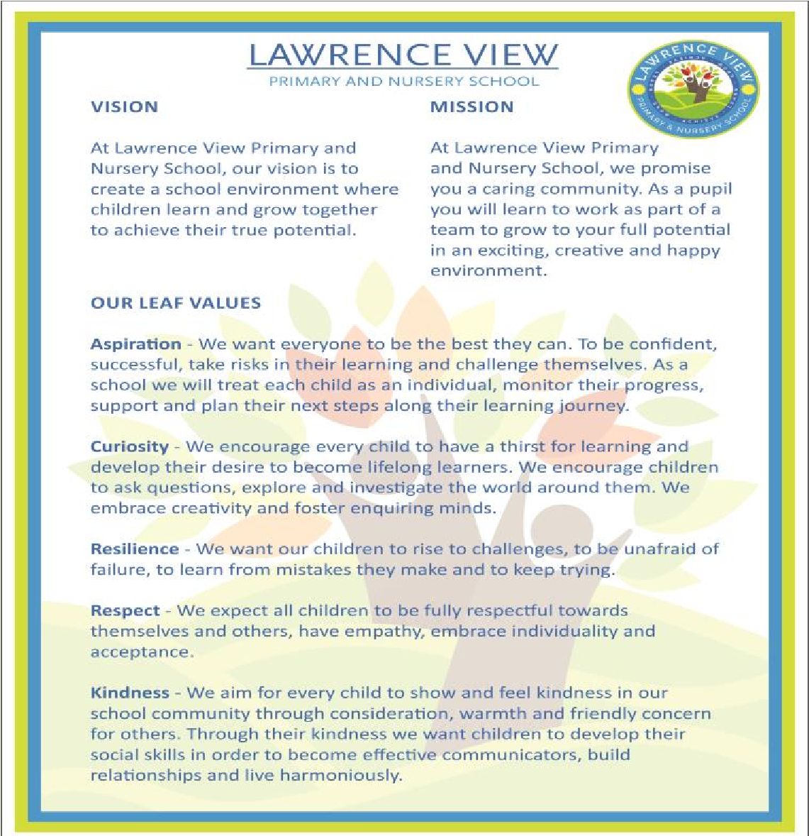

Emotional Coaching Steps of Emotion Coaching 
We use Emotion Coaching to support children to understand, regulate and reflect on their behaviour. We advocate that our parents use this method too and regularly hold training and coffee mornings for parents to learn this approach and share their own experiences.
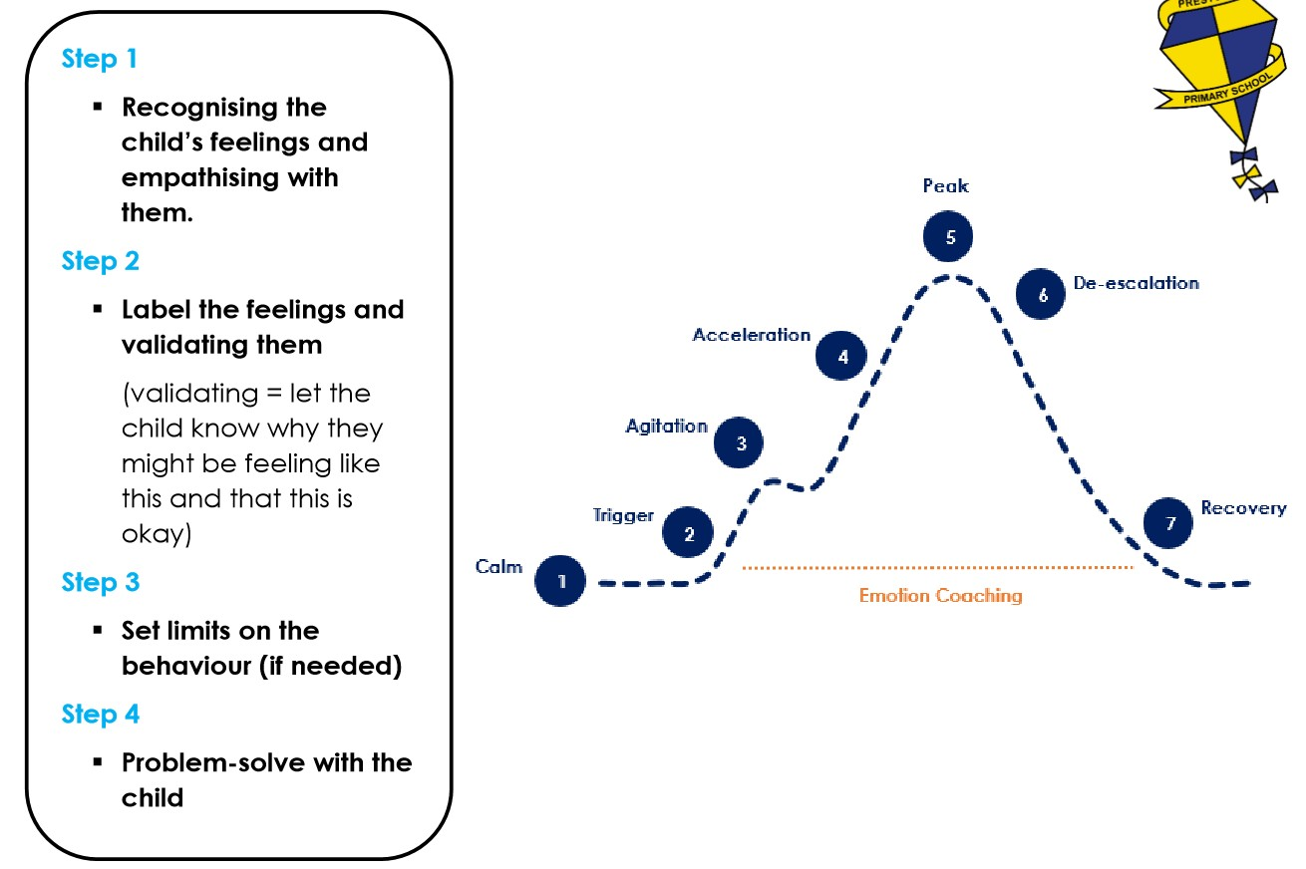
To help children learn to understand how a feeling relates to an emotion, children are encouraged to reflect on which Zone of Regulation they are in.
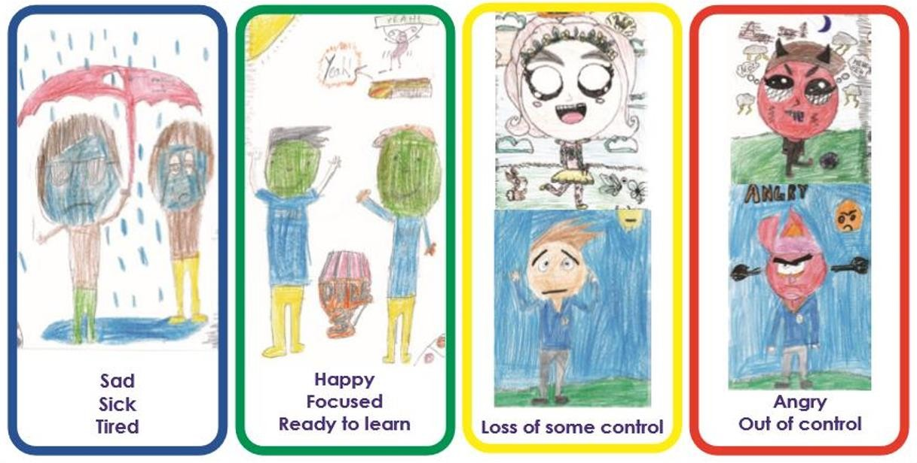
All staff wear lanyards attachments which outline the steps of emotional coaching and the zones of regulation to support conversations with children.

Emotional Coaching Provision Map
The relationship a class teacher and support staff forms with pupils is central to the pupils personal social and emotional development. They are expected to use a range of approaches set out in the provision map to support the development of pupil self-regulation. Staff work collaboratively with each other and the wider pastoral team. The teachers have regular guidance on how to support pupils through emotion coaching and restorative conversations.

The wider school community
Nurture provision

Pastoral drop in ELSA

Forest School

Drawing and talking

Positive play

Hut Club School ethos

Staff Relationships Therapat

Emotional Coaching | Restorative conversation
- Noticing, being aware of pupil’s feelings and empathising with them.  - Labelling and validating pupil feelings.  - Set limits on behaviour.  - Help pupil to problem solve. | - What happened?  - Who was affected?  - What were you feeling? (you may need to emotion coach) What were others involved feeling?  - How can we make things right?
Positive awards are available for pupils throughout the day. These aim to promote confidence, competency, motivation, help pupils to develop growth mind-sets and promote prosocial behaviour. These include:
- To show the feeling of mutual respect within the school, each pupil will be greeted in the morning with a handshake or greeting (COVID) from their teacher.
- Dojo points for those children demonstrating behaviour above and beyond the general expectations of the school.
- The teachers will use a variety of techniques including thumbs up, round of applause, stickers etc to highlight good examples to the rest of the class.
- Teachers may ask children to show their work to others teachers or senior leaders.
- Each classroom will have a wall of fame board where the names of children going above and beyond general good behaviour will be displayed. These names will be displayed for the day.
- Children demonstrating exceptional behaviour will receive a postcard home outlining the reasons they have been highlighted as a good example to others.
- Each week a child from each class will be selected as the Example of the week for an aspect of their behaviour. These children will have a special meeting time with the staff in the staffroom where they will share a drink and a snack together.

Those children who choose not to be ready to learn, do not show respect for themselves, others or property or demonstrate behaviour that is unsafe will receive sanctions. All members of staff will follow the following steps.
- A verbal warning using the three themes of our policy (ie you are not showing respect because…)
- The child’s name to be written on the board- or a post it note.
- Removal to another area within the classroom
- 5 mins of reflection at playtime to be taken in a timeout area – followed by a restorative conversation with a member of staff.
- 10 mins of reflection at playtime to be taken in a timeout area – followed by a restorative conversation with a member of staff.
- Removal to another classroom
- Parents / carer to be spoken to by the class teacher.
- Parents / carer to be spoken to by a member of the senior Leadership Team / Head teacher
- A short period of alternative provision based on the child’s need.

For a small number of children who need persistent adult support to regulate behaviour, alternative and more detailed provision will need to be put in place. This will be outlined in a specific individual behaviour plan.

Monitoring and reporting behaviour patterns
Every adult is able to report behaviour using our CEPOMS system. This system is monitored by senior leaders and the behaviour lead. The behaviour lead produces a report of any behaviour patterns emerging to the senior leadership team, where strategies are implemented and adapted to suit the child’s individual needs.
Patterns, trends, actions and impact are reported to the Governing Board termly. No individual pupils are identified.
Support for adults to ensure consistency:
All new staff attend induction training during which includes the ethos of our school and this policy is outlined and explained along with Emotion Coaching. All staff have received training which is reviewed regularly. Supply or short term staff are inducted into school systems on arrival through the class supply information sheet. Staff get feedback on learning and other forms of pupil encouragement and engagement and motivation in lesson observations and sharing best practice with colleagues.

Additional Needs
We acknowledge that some pupils’ behaviour may reflect social, emotional and mental health needs which may require additional provision to what is outlined in this policy. The SEND policy should be read for how additional needs are supported in the school.

Exclusion
In our school it is rare that school support will not have a positive impact upon pupil behaviour development and regulation. However, the school does and will exclude pupils for persistent abusive or violent behaviour or repeated and escalating low level disruptive behaviour. It is our ethos that we will make every provision for a child to achieve socially and emotionally but if, in spite of this, behaviours are risky, unsafe, violent and prevent the efficient education of others, fixed term or permanent exclusion may be applied.
We abide by the DfE guidance on this and report any exclusions routinely to Nottinghamshire LA following local and national guidance.
(https://www.gov.uk/government/uploads/system/uploads/attachment_data/file/641418/20170831_Exclusion_Stat_guidance _Web_version.pdf)

Risk assessment
At times at Lawrence View it may be necessary to conduct a risk assessment for the particular behaviours displayed by a child. We will attempt to reduce risk by managing:
- The environment
- Our body language
- The way we talk to the children
- The way we act
- And by personalising curriculum and other learning programmes
All of our staff have been trained in CRB techniques and positive safer handling.

Policy updated – November 2025 Next review date – November 2027

