
Lawrence View Primary and Nursery School

Standardised Deployment of Teaching Assistant Policy
2026

Purpose of This Document

This document outlines a whole-school approach to the effective deployment of Teaching Assistants (TAs). It draws on evidence-informed guidance, including the EEF's Deployment of Teaching Assistants and Making Best Use of Teaching Assistants guidance reports, as well as wider research on adaptive teaching and high-impact classroom support. The aim is to ensure consistency, maximise impact on pupil outcomes, and embed a shared understanding of expectations across the school.

Content
- Whole-School Principles for TA Deployment
- Roles and Responsibilities
- Deployment Expectations in Classrooms
- TA use in interventions
- Adaptive Practice and TA deployment
- Professional Development and Training
- Monitoring and Evaluation
- Appendices

1.Whole-School Principles for TA Deployment

1.1 Evidence-Informed Practice
-TA deployment decisions are guided by research evidence.
-TAs will supplement, not replace, high-quality classroom teaching.
-TA support will be intentionally planned rather than reactive.

1.2 Consistency and Clarity
-All staff will understand the purpose and expectations of TA involvement.
-TA roles and responsibilities will be consistent across classrooms and year groups.
-Adaptive practice should be central to deployment, allowing flexibility within the consistent framework.

1.3 Focus on Independence
-TAs should aim to promote pupil independence, not learned dependency.
-Interactions should encourage pupils to think, reason, and self-regulate.

Roles and Responsibilities

Teaching Assistants
-Deliver structured interventions as directed by classroom teacher, SENCo or leadership.
-Provide targeted, purposeful classroom support.
-Use scaffolding strategies rather than completing tasks for pupils.
-Maintain high expectations for all learners.
-Communicate regularly with teachers regarding pupil needs.

Teachers
-Plan for TA deployment within lessons.
-Provide clear guidance on instructions, learning objectives, and success criteria.
-Ensure TAs are informed of pupils' learning needs and curriculum content.
-Review TA impact on learning and adapt deployment as needed.

Leaders
-Ensure systems are in place for consistent TA deployment.
-Provide ongoing professional development aligned with evidence-based practice.
-Monitor TA impact and adapt strategy in response to findings.

Deployment Expectations in the Classroom

Pre-Lesson Briefing
Teachers provide a clear plan for TA involvement, this may be seen on the medium-term plan, a discussion between class teacher and TA prior to lesson or on the format seen in the appendices. The plan will highlight:
-Intended learning outcomes.
-Target pupils/groups.
-Scaffolding strategies and prompts.
-Key vocabulary and misconceptions.
-TAs should have access to planning documents in advance.

In-Lesson Support
-TAs work with pupils who need additional guidance, not exclusively the lowest-attaining pupils.
-Support should prioritise enabling access to high-quality instruction delivered by the teacher.

TAs use agreed scaffold strategies such as:
-Open questioning
-Prompts for metacognitive thinking
-Chunking tasks
-Clarifying instructions without over-helping

Post-Lesson Debrief
Quick feedback loop at the earliest possible time after the lesson. This will include information regarding:
-What worked well?
-Which pupils require follow-up support?
-Adaptations needed for next lesson?

TA Use in Interventions

Structured Intervention Principles
-Interventions must be structured, evidence-based, and time-limited.
-TAs delivering interventions receive appropriate training.
-Sessions should be closely linked to classroom learning.

Monitoring Intervention Impact
-Progress should be tracked using reliable measures. These assessment measures will depend on the intervention taking place.
-Teachers and TAs share responsibility for reviewing effectiveness.
-Interventions should stop or adjust when evidence indicates limited impact.

Adaptive Practice and TA Deployment

Adaptive Teaching Fundamentals
-Adaptations should maintain high expectations for all learners.
-TAs help facilitate access to the curriculum—not reduce challenge.

TA Role in Adaptive Practice
-Provide targeted scaffolding for pupils needing additional support.
-Help pre-teach key concepts/vocabulary where appropriate.
-Support formative assessment by communicating observations to teachers.
-Adjust support in real time to promote independence.

Professional Development and Training

Induction
All TAs receive structured induction including:
-Overview of evidence-informed TA practice.
-School expectations and processes.
-Safeguarding and behaviour training.

Ongoing CPD
Regular training on:
-Adaptive teaching strategies.
-Effective scaffolding.
-Intervention delivery.
-Supporting SEND and EAL learners.

Monitoring and Evaluation

7.1 Leaders Will:
-Observe TA deployment regularly. Following our monitoring document.
-Review TA contribution to pupil progress. This will be noted and reviewed within the termly pupil progress meetings.
-Ensure consistency across year groups.
-Provide coaching and development where required.

7.2 Teachers Will:
-Reflect on effectiveness of TA deployment.
-Adapt planning accordingly.
-Work collaboratively to maintain consistency.

Appendices

Appendix A: TA Scaffolding Toolkit
Appendix B: Pre-Lesson Briefing Template
Appendix C: Intervention Recording Template

This document is designed to support the consistent, evidence-informed, and purposeful use of TAs across the school.

Appendix A: TA Scaffolding Toolkit
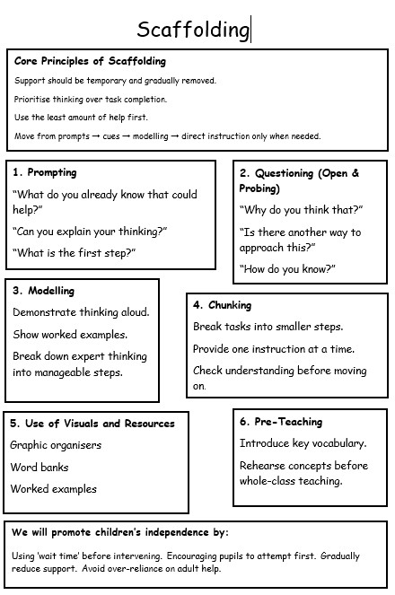

Appendix B: Pre-Lesson Briefing Template

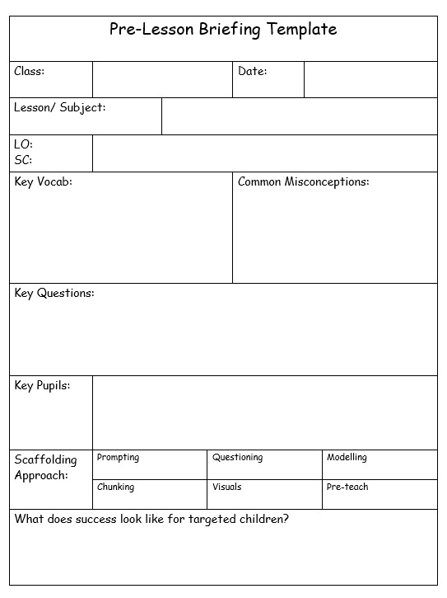

Appendix C: Example of Intervention Recording Template



