Unique Is Me Day
To help us celebrate everything that makes our children and families unique, we'd love you to complete the two activities below with your child and send them into school for our display.
1. What Makes My Child Special?
On the card, write one thing that makes your child special. This could be a quality, strength or characteristic that makes them who they are.
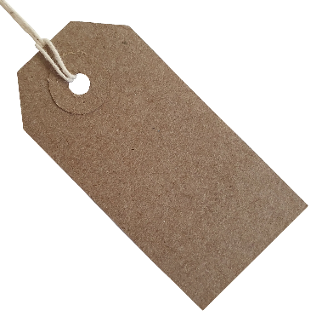
Examples:
Tracy Jones is
- kind and caring.
- never gives up when things are difficult.
- makes people smile.
- curious and love learning new things.
- is always willing to help others.
And then sign the card.
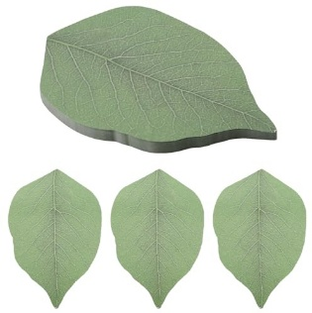
2. Family Values Leaf
On the leaf, write one value that is important to your family and a short sentence explaining why it matters to you.
Examples:
- Kindness – We believe it is important to be kind to everyone.
- Respect – We treat others the way we would like to be treated.
- Honesty – We always try to tell the truth.
- Determination – We keep trying, even when things are challenging.
- Love – We support and care for one another.
Thank you for helping us celebrate the wonderful qualities, traditions and values that make each child and family unique. We can't wait to share your contributions on Unique Is Me Day!

Community Scarecrow Workshop
We would also like to invite parents and carers to join us on Friday 4th September from school drop-off to help create our class scarecrows.
Each year group will be decorating a scarecrow around a special theme linked to our Unique Is Me Day celebrations:
- EYFS: This Is Me
- Year 1: The Things We Love
- Year 2: Our Families
- Year 3: Our Strengths
- Year 4: Our Community
- Year 5: Dream Big
- Year 6: My Legacy
Please bring any resources you would like to use with your child, such as old clothes, accessories, photographs, craft materials or themed items. We will provide the scarecrow poles, tape, string and cable ties.
We would also gratefully receive donations of:
- Newspaper
- Old white pillowcases
- Old pillows (for stuffing)
The finished scarecrows will be displayed around the school for everyone to enjoy at the end of the school day. We hope you can join us for this fun opportunity to celebrate our children's individuality and creativity!

