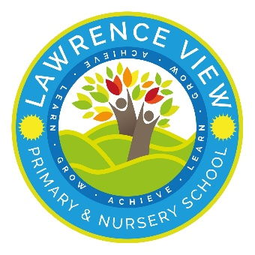
Free Breakfast Club and New Morning Arrival Arrangements from September

Dear Parents and Carers,

We are pleased to share that, from September, we will be offering a Breakfast Club for children in F2 to Year 6. Please see the attached flyer for further information.

Breakfast will be provided free of charge for all eligible pupils from 8:10am to 8:50am.

Children may also attend Breakfast Club from 7:30am;however, places before 8:10am will be chargeable.

All Breakfast Club places, including both the free and paid sessions, must be booked in advance through Arbor.
Any child who arrives between 8.10am and 8.30am must be prebooked on Arbor.

Morning Arrangements
- Children attending Breakfast Club should enter via the main school reception entrance upto 8.30am.
- From 8:30am, the Walker Street gate will be open for all pupils.
- ALL Children (Yrs 1,2,3,4,5and 6) should enter the school building through the main playground door (not classroom doors) and go directly to their classrooms. External classroom doors will not be used for morning entry, except for Foundation Stage children who will continue to use their classroom doors.
- THE MAIN RECEPTION GATES WILL BE CLOSED FROM 8.30am- Walker street will remain open until 8.50am
- Toast and bagels will be available in classrooms each morning for any child who would like something to eat on arrival.
To support site security and help children develop their independence, we encourage parents, wherever possible, to allow their children to walk independently along the pathways into school.

Teaching Assistants will be in classrooms ready to welcome children and support a calm and positive start to the day.

Staff will also be available at the main entrance and Walker Street gate to support families during arrival.

We hope these arrangements, alongside our breakfast provision, will help children start each day ready to learn.

Thank you for your continued support.

Kind regards,
School Leadership Team



