

Pupil Belonging Survey results September 2026
At Lawrence View Primary School, we want every child to feel safe, valued and proud to belong to our school community.
Recently, 150 pupils completed our Pupil Belonging Survey. The questions explored how pupils feel about friendships, trusted adults, safety, learning, participation and having their voices heard. The results were very positive, with the large majority of responses showing that pupils feel connected to and supported by our school.
*All responses are rounded up for this table creation.
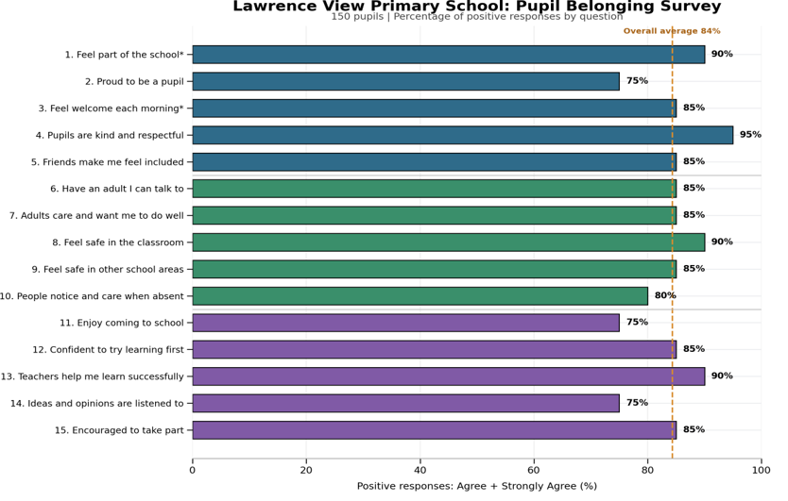

What our pupils told us
Our pupils told us that:
- 95% feel that other pupils are usually kind and respectful.
- 90% feel safe in their classroom.
- 90% believe their teachers understand how to help them learn successfully.
- 85% have friends who help them feel included.
- 85% know an adult they can talk to if they are worried.
- 85% feel that adults care about them and want them to do well.
- 85% feel encouraged to take part in lessons and school activities. [table | Word]
There were no strongly disagree responses to any of the 15 statements. This provides strong evidence that pupils generally experience positive relationships, effective support and a secure sense of belonging at school.

In Their Own Words
As part of the survey, pupils were invited to tell us more about their experiences at Lawrence View.

What is the best thing about being part of our school?
Pupils talked positively about their teachers, friendships and the range of opportunities available to them. Their comments included:
“Teachers make me feel confident.”
“I have lots of friends.”
“People are kind and everyone gets included.”
“It is fun.”
“There are lots of trips and things to do.”
“I get to play football.”
Pupils particularly value friendships, playtimes, trips, activities and the way adults help them feel confident.

What helps pupils feel that they belong?
Pupils spoke warmly about the care and support they receive from teachers and other children:
“Teachers make me feel safe.”
“Teachers help me learn and grow.”
“Everyone wants me to belong.”
“My friends make me feel included.”
“I know I can be me.”
“It doesn’t matter if I am different from other children.”
Pupils told us that kind and caring teachers, supportive friendships and being included help them feel that they belong. Their comments also show that pupils value being able to be themselves and feel accepted, even when they are different from others.

What could we do to help pupils feel even more included and connected?
Pupils provided thoughtful suggestions about how adults could strengthen inclusion and participation. They would like adults to:
- Talk to children more about their interests.
- Select a wider range of pupils to answer questions when their hands are raised.
- Allow pupils time to ask questions before moving on with learning.
- Provide more opportunities for free time.
- Consider when pupils could sit with their friends during lessons.
- Continue to be understanding of pupils’ individual needs.

You Said, We Will
We are proud of the positive feedback, but we are also committed to listening closely and taking meaningful action.
In response to the survey, we will:
- Continue to ensure that every pupil has a trusted adult they can talk to.
- Give pupils further opportunities to talk about their interests and experiences.
- Review how pupils are selected to contribute during lessons, so a wide range of voices is heard.
- Make sure pupils have appropriate opportunities to ask questions and clarify their learning.
- Continue to consider pupils’ individual needs when organising learning and classroom activities.
- Strengthen opportunities for pupils to contribute to decisions about school life.
- Show pupils what has changed as a result of their ideas and feedback.
- Continue to celebrate the differences that make every member of our school community unique.
The children’s written responses reinforce the survey findings. Pupils broadly feel safe, included and supported by kind and caring adults. They value their friendships and appreciate the opportunities available to them. Their suggestions also provide a clear focus for making sure every pupil feels heard, understood and able to participate.
We will continue to listen to our pupils and evaluate the impact of the actions we take. Their views are an important part of ensuring that every child feels they belong at Lawrence View Primary School.

