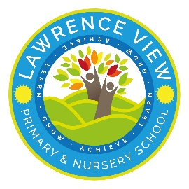
 | Autumn 1 | Autumn 2 | Spring 1 | Spring 2 |  |  | Summer 1 |  |  |  |  |  | Summer 2
The Literacy curriculum  Quality Texts  Traditional Tales | Quality texts  The Naughty Bus  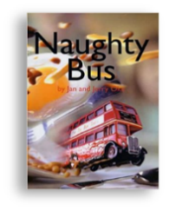  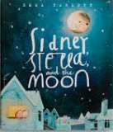  Sidney, Stella and the Moon  Traditional Tales  3 little pigs  Goldilocks and the 3 bears | Quality texts  I Want my Hat Back  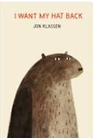  Billy and the Beast  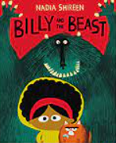  Traditional Tales  Little red riding hood  Jack and the beanstalk | Quality texts  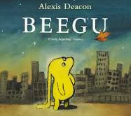  Beegu  The Odd Egg  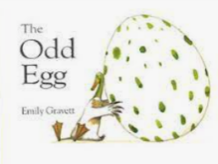  Traditional Tales  Hansel and Gretal  The princess and the pea | Quality texts  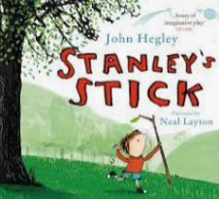  Stanley’s Stick  The Sea Saw  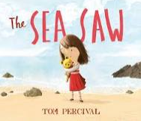  Traditional Tales  The elves and the shoemaker  Rumpelstiltskin |  |  | Quality texts  Lost and Found  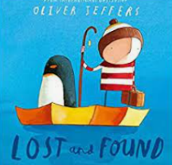  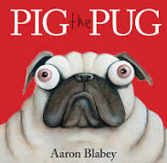  Pig the pug  Traditional Tales  Pinocchio  The ugly duckling |  |  |  |  |  | Quality texts  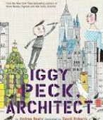  Iggy Peck Architect  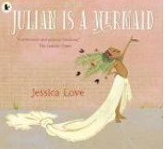  Julian is a mermaid  Traditional Tales  Chicken licken  The lion and the mouse
Wow Starter | The moon has gone missing. | WANTED: Missing Hat. | Alien visitor. | Stick hunt. |  |  | Penguin arrives in the classroom. |  |  |  |  |  | Building challenge.
Enrichment | Walk into our local town. | Trip to Sudbury Hall. | Trip to Sherwood forest | Trip to East Midlands airport. |  |  | Trip to Cleethorpes.
Community links  Charity partner- Dogs for the blind | Going into the community | Sharing toy memories with grandparents. | Creating art work for the community. | Going into the community. |  |  | Going into the community . |  |  |  |  |  | Going into the community.
School values | Respect – respect for everyone around us and people’s belongings. | Resilience - learning how to become a resilient learner. | Kindness – sharing of toys and appreciating things from the past need to be taking care of. | Curiosity – develop question and wonder for the things around us in our local area. |  |  | Aspirations – for the places around us and the opportunities in life we could have. |  |  |  |  |  | Curiosity- develop question and wonder about the world around us.
British values | The Rule of the Law | Rule of the Law | Individual Liberty | Mutual Respect |  |  | Democracy |  |  |  |  |  | Tolerance
Personal Development | Families  Responsibilities  Permission seeking language | Caring  Friendships  Managing simple conflict  Fairness | Respectful relationships  Personal safety  Body autonomy | Safety in and around the home  Safe vs unsafe behaviour |  |  | Democracy  Community  First Aid |  |  |  |  |  | Changing and Growing (SRE)  Economic  Wellbeing
Personal Development | Ongoing; Mental health, ZUMOS, Current affairs, Sun Safety
History  Key Question and Theme | Which toy would you choose?  changes within living memory  History Theme: Home Life |  | Who was the lady with the lamp?  the lives of significant individuals in the past who have contributed to national and international achievements |  |  |  | Why is our school called D H Lawrence?  Local History  History: Settlement
History | - Describe how teddies have changed over a period of time  - Sequence different toys on a timeline  - Identify similarities and differences between toys from the past and now  - Explain which toy from the past they would choose to play with and why  Historical Skills  - Sequence events or objects in chronological order  - Organise artefacts by age  - Begin to identify different ways to represent the past (e.g photos, stories, adults talking about the past)  - Ask questions related to objects and historical sources  - Finds answers to simple questions about the past using information sources |  | - Explore who Florence Nightingale was and why she is remembered.  - Consider the differences between nursing in the past and now.  - Think about how people’s jobs and roles have changed over time.  Historical Skills  - Sequence events in chronological order using a simple timeline of Florence’s life.  - Organise historical sources (photos, drawings, artefacts, diary extracts) to show past vs present.  - Begin to identify different ways to represent the past  - Ask questions about objects and sources  - Find answers to simple questions using books, pictures, and short videos. |  |  |  | - Know who D H Lawrence was and why our school is named after him.  - Know why Eastwood has links to D H Lawrence  - Identify similarities and differences between aspects of their own lives and those of past times.  - Ask questions about D H Lawrence, our school and Eastwood and find answers  Historical Skills  - Sequence key events in D. H. Lawrence’s life on a simple timeline.  - Use historical sources to find out about Lawrence, Eastwood, and the school’s history.  - Identify different ways the past can be represented  - Ask and answer questions about D. H. Lawrence, Eastwood, and how the school has changed.  - Compare aspects of their own lives with those from Lawrence’s time  - Create a class display/museum using annotated photographs, artefacts, and ICT to share what they have learned.
History Enrichment | Visit Sudbury Hall Childhood Museum  Handling Toys artefacts box  New and old toys  Letters from grandparents |  | Florence Nightingale resource box / artefacts from Nottingham Museums  Online / digital exhibitions: “Florence Nightingale Comes Home”  Workshop / talk with a nurse / local health visitor |  |  |  | Visit DH Lawrence Museum  DH Lawrence society talk  Walk around the local area (DH Lawrence walk)
History Texts | 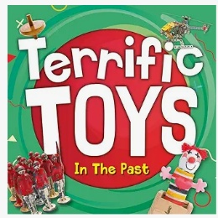  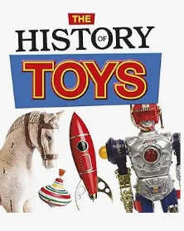 |  | 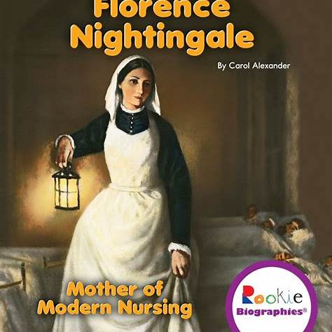  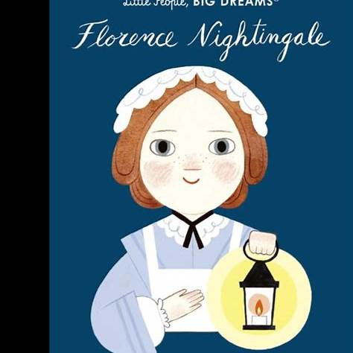
Geography  Key Question and Theme | What makes Eastwood unique?  Geography-Locational and place knowledge.  Key Concepts: Place, Space, Scale. |  | What can be found on the Equator?  Geography- Field skills and Place knowledge  Key Concepts: Place, space, scale, cultural understanding and diversity, physical and human processes. |  |  |  | How is Eastwood different to London?  Geography- Local Area – London city or Village  Key Concepts: Place, space, scale, physical and human processes, cultural understanding and diversity.
Geography  Key Question and Theme | - Know that our town is called Eastwood and our nearest city is Nottingham.  - Know their address and postcode.  - Identify features and landmarks in Eastwood.  Recovery from F2  -Know the name of the town our school is in is Eastwood.  Geography Skills  - Devise a simple map and label it.  - Use aerial photographs and plan perspectives to recognise landmarks.  - Name Eastwood as a town and locate this in an atlas/on a map.  - use simple fieldwork and observational skills to study the geography of their school and its grounds  Recovery from F2: That a globe is a model of the Earth and that maps show countries of the world. |  | - Know where the equator, Northern hemisphere and Southern hemisphere are on a globe and on a map.  - Know features of hot and cold places in the world (Greenland and Madagascar) – Kalaallit tribe in Greenland and the Merina Tribe in Madagascar, animals, plants, weather.  - Locate the UK, Greenland and Madagascar on a map.  - Know that countries on the Equator are hot all year round.  - Know which the hottest and coldest season in the UK is.  - Know and recognise main weather symbols.  Geography Skills  - Know where the Equator, North Pole and South Pole are on a globe and a map.  - Use simple fieldwork and observational skills to study the geography of their school and its grounds. |  |  |  | - Know the names of the four countries that make up the UK and name the three main seas that surround the UK.  - Know the main differences between a city, town and village.  - Know that London is the capital city of England- name some .  - Compare London landmarks and Eastwood landmarks.  - Know the difference between human and physical features in our immediate school environment.  - Know the difference between human and physical features of our wider local area – The Major Oak and Nottingham Castle.  Geography Skills  - Know the points N, E, S and W on a compass and be able to use and follow simple compass directions.  - Use aerial photographs and plan perspectives to recognise landmarks.  - Use world maps, atlases and globes to identify the United Kingdom and its countries and its surrounding seas.  - Name Eastwood, Nottingham and London and locate these in an atlas/on a map  - Devise a simple map and label it.  - Begin to know the difference between basic human and physical features on a map and in their surrounding environment/school grounds.  - Use simple fieldwork and observational skills to study the geography of their school and its grounds and the key human and physical features of its surrounding environment.
Geography Fieldwork and Geography enrichment. | Where on our school grounds would be a good place to launch the moon back into space?  - Surveying the school grounds for a suitable place to launch the moon back into space. Linked to class text. |  | Where has Beegu gone?  - Plotting routes on maps to find the Beegu and his belongings in our school grounds.  External speaker – James Ketchell who has trekked across Greenland.  External speaker – Miss Robinson’s friends who live in Madagascar. |  |  |  | What human and physical features can we find on our school grounds?  - Devise a simple map and label it with human and physical features of the school grounds.  - Know the points N, E, S and W on a compass and be able to use and follow simple compass directions.  - Use simple fieldwork and observational skills to study the geography of their school and its grounds and the key human and physical features of its surrounding environment.
Science | Animals including Humans  - Know the name of parts of the human body that can be seen  - Measures (within Year 1 mathematical limits) to help find out more about the investigations undertaken | Seasons  - Name the seasons and know about the type of weather in each season  - Name the seasons and know about the type of weather in each season  - Know which the hottest and coldest season in the UK is.  - Know and recognise main weather symbols | Animals  - Know how to classify a range of animals by amphibian, reptile, mammal, fish and birds  - Know and classify animals by what they eat (carnivore, herbivore and omnivore)  - Know how to sort by living and non-living things | Plants  - Identify and name a variety of common, wild and green plants, including deciduous and evergreen trees;  - Identify and describe the basic structure of a variety of common flowering plants, including trees.  - Know the names of a variety of common wild and garden plants  - Know the names of a variety of common trees  - Know the difference between deciduous and evergreen trees  - Know which plants grow in the local environment |  |  |  |  |  | Materials  - Know the name of the materials an object is made from  - Know about the properties of everyday materials  - Materials -Set up a test to see which materials are absorbent know if the test has been successful and can say what has been learned  - Explain to someone what has been learned from an investigation they have been involved with and draw conclusions.
Art and Design | Buildings  Architectural drawing of houses & local buildings from direct observation and secondary sources.  Artist: Stephen Wiltshire, Paul Klee  Architect - Norman Foster, Sarah Wigglesworth  - Explore a range of drawing tools e.g. sketching pencils, pencil crayons and pastels.  - Know that different sketching pencils make different marks.  - Know how to use 2 different gradient of pencils.  - 2B and 8B Pencils Chalk Pastels Pencil/s Crayon/s Draw lines of different size and thickness and explore shapes.  - Begin to make observational drawings.  - Colour (own work) neatly following the lines.  Pencil crayon  Pencil/s Crayon/s Thick/ness Thin Line Grade  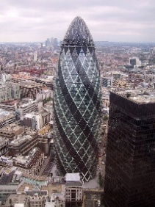 |  | Circles  Colour mixing primary and secondary colours  Colour in moods and repeated patters.  Artist - Kadinsky  Powder paint  - Use thick and thin paint brushes.  - Know the names of the primary and secondary colours.  - Mix primary colours to create secondary colours.  - Water colour / powder paint  - Discuss and use warm and cold colours.  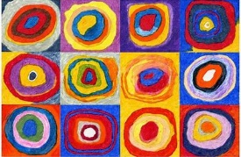  Painting primary secondary thick thin brush/es colour |  |  |  | Using IT to create a picture.  Pablo Laboto  - Begin to explore digital media to create an image.    Explore digital tools e.g. brushes, shape, fill tools and erase. |  |  |  |  | Cut, roll and coil materials.  Michelle Reader  - Enjoy handling, feeling and manipulating a range of materials. (wire, paper and straws.)  - Cut shapes using scissors in a safe way.  - Build a construction using straws and paper.  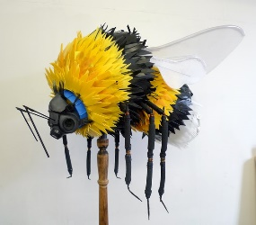
Art and Design | Artist – Describe the work of notable artists. Describe what can be seen and give an opinion. Use some of the ideas of artists studied to create pieces.
DT | Textiles – puppets |  | Mechanisms – moving storybook |  |  |  | Cooking and nutrition – fruit and vegetables
RE  Nottinghamshire Agreed Syllabus | 1.1  Celebrations and festivals  Who celebrates what and why?  Christians and Jewish people | RE day- Focus on Christmas  Invite visitor  Focus- drama and art  Visit to a church | 1.2  Myself and caring for others  How do we show we care for others? Why does it matter?  Christians and Jewish people  Humanism |  | 1.3  Beliefs and teachings  Stories of Jesus  What can we learn from them?  How to religious stories make a difference to people’s lives. |  | 1.4  Symbols in religious worship and practice  In what ways are churches/ synagogues important to believers?  Christians and Jewish people |  |  |  |  | RE day- Focus- Express yourself spiritually through the arts  Music, drama, art
PE | Invasion games | Invasion games | Gymnastics and dance |  |  |  | Invasion games |  | Striking and fielding |  | Athletics.
Music | Hey you  Begin to recognise styles, find the pulse, recognise instruments, listen, discuss other dimensions of music.  How pulse, rhythm and pitch work together. When we rap we use pulse and rhythm but add pitch and we have a song. | Rhythm in the way we walk  The banana rap  Learning new musical skills/concepts and revisiting them over time and with increasing depth | In the groove  Begin to recognise styles, find the pulse, recognise instruments, listen, discuss other dimensions of music.  How pulse, rhythm and pitch work together. When we rap we use pulse and rhythm but add pitch and we have a song. |  |  | Round and round  Playing/singing in different styles and learning about those styles |  | Your imagination  Create your own lyrics. Mixed styles and listening to songs/music about using your imagination: |  |  | Reflect, rewind and replay  About the dimensions of music and how they fit into music: pulse - a steady beat, simple rhythm patterns, pitch, texture, tempo, dynamics.
ICT | On line safety  Using technology | On line safety  Using technology | Algorithms  create a series of instructions and plan a journey for a programmable toy |  |  | On line safety  Using technology |  | Create Programmes  create, store and retrieve digital content |  |  | Create Programmes  create, store and retrieve digital content
Curriculum links with Mathematics | Science – Materials- Describing position when completing scientific investigations.  DT – Using 2D and 3D shapes when making a structure stronger. Positional language when moving shapes  Music – Discussing and counting beats and pulses | History - Sequence events in chronological order using language [for example, before and  after, next, first, today, yesterday, tomorrow, morning, afternoon and evening]  Recognise and use language relating to dates, including days of the week, weeks,  months and years  DT – Using 2D and 3D shapes when making a structure stronger. Positional language when moving shape. | History – Counting objects and artefacts. Sequence events in chronological order using language [for example, before and  after, next, first, today, yesterday, tomorrow, morning, afternoon and evening]  Recognise and use language relating to dates, including days of the week, weeks,  months and years  Music – Discussing and counting beats and pulses.  ICT– Counting and sequencing events when creating a series of instructions.  DT – Measuring and beginning to recording measurement of ingredients when cooking.  Science- Seasons - Recognise and use language relating to dates, including days of the week, weeks,  months and years. |  |  | History - Sequence events in chronological order using language [for example, before and  after, next, first, today, yesterday, tomorrow, morning, afternoon and evening]. |  | Geography - Count, read and write numbers to 100 in numerals. |  |  | Science- measure and begin to record the following:  ▪ lengths and heights. compare, describe and solve practical problems for:  ▪ lengths and heights [for example, long/short, longer/shorter, tall/short,  double/half]

